To Make This Game: Print the hearts below (page 2) on cardstock. Laminate the cardstock. Cut-out the hearts and glue each one to a clothespin.

Objective: This is a great lesson on making fact families.

How to play:
Set up: Break your students up into teams of two. Give each team a coffee can (you can decorate the outside of each can or just give them a plain can). Give each person in the team 10 clothespins. Give each team a game sheet to fill out (page 3).

Let’s Play: Partner 1 stands above the coffee can and holds one heart up by his or her nose. He or she tries to drop each heart one at a time into the can until all ten are gone. When he or she is finished, she counts up how many she/he got in the can and how many fell on the floor. “I got six hearts in the can and four fell on the floor.” He/she then writes a math problem on his or her record sheet. 6+4 = 10. They should also circle the number in the problem that shows how many they placed into the can. In this case, the student would circle the number 6.

Now, it is the other partner’s turn to do the same thing with his or her heart clothespins. He or she tries to drop each heart one at a time into the can until all ten are gone. When he or she is finished, she counts up how many she/he got in the can and how many fell on the floor. “I got 3 hearts in the can and 7 fell on the floor.” He/she then writes a math problem on his or her record sheet. 3+7=10. They should also circle the number in the problem that shows how many they got into the can. In this case, the student would circle the number 3.

Repeat this sequence three more times each for a total of four tries for each partner.

After each partner has had four tries at dropping the heart into the can, the team should finish filling out the game sheet.

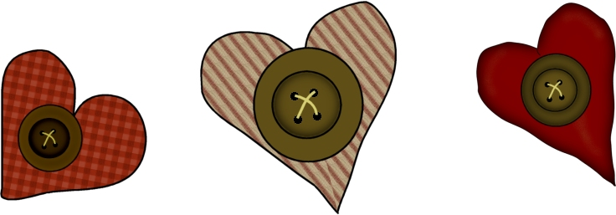

Heart Graphics Copyrighted by Dona at http://www.gonecountrygraphics.com/ and used with permission. Sheet Copyright 2005 by Colleen Gallagher at http://www.teachingheart.net



Partner 1 Name: _____________________________ Partner 2 Name: ___________________________

We each had ______ clothespins. Today’s date is ___________________________________________

Let’s Play: Write a problem for each set of clothespins. Be sure to circle the number that you got in the can for each turn.

Partner 1 | Partner 2
_____ + _____ = _____ | _____ + _____ = _____
_____ + _____ = _____ | _____ + _____ = _____
_____ + _____ = _____ | _____ + _____ = _____
_____ + _____ = _____ | _____ + _____ = _____



Who dropped the most hearts into the can?

Partner 1 circled the numbers ______________________________________________________________

If I add these numbers together, I get the sum ______________________________________________

Partner 2 circled the numbers ______________________________________________________________

If I add these numbers together, I get the sum ______________________________________________

Which partner dropped the most hearts into the can? ________________________________

Which partner dropped the least hearts into the can? ________________________________

All Graphics Copyrighted by Dona at http://www.gonecountrygraphics.com/ and used with permission. These graphics may not be used anywhere else except on this sheet unless permission is given by Dona. Sheet Copyright 2005 by Colleen Gallagher at http://www.teachingheart.net

