Note To Teacher:

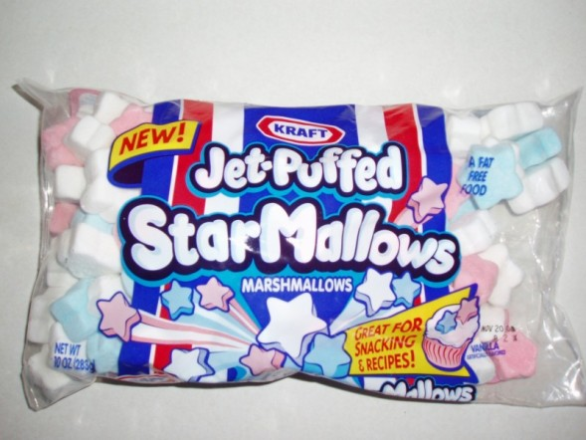
Use the Jet-Puffed StarMallows to complete these math activities.

ACTIVITY 1: SORTING AND GRAPHING SHEET: Purchase Jet-Puffed Star Mallows at your local store during the summer season. Place a few in a cup for each student. First have the students sort their stars, next have them complete the graph.

Below is a picture of what the Marshmallows look like:

ACTIVITY 2: BUNNY EQUATIONS: Split students into groups of two. Supply each team 12 stars in a cup and 1 die. Each student should complete their own star equation sheet (page 4).
The first student rolls the die, and counts out that many marshmallow stars. Each student writes the number on his/her equation sheet. Then the second student rolls the die and counts out that many stars. Each child writes that number on his/her equation sheet. The plus sign and equal sign are already on the sheet. Then they combine their marshmallow bunnies to see how many they have in all. Last, they record their answer. After putting the stars back in their cup they follow the same procedure to write their next equation. Each pair of students needs to do five equations. Then they work together to read & complete the tasks below the equations.


Name:______________________________________ Date:_________________________
Sort your marshmallow stars into the correct box. Count each set of stars and write the total of each color in the circle.

Red | White
Blue | Color

Name:___________________________________________ Date:____________________
Color Your Graph!
Graphing Your Stars!

Red
Stars

Blue
Stars

White
Stars

Answer these questions about your graph!

1.) What color stars do you have the most of? ______________________________________

2.) What color stars do you have the least of? _______________________________________

3.) Do you have more red or blue stars? ____________________________________________

4.) Do you have more white or red stars? ___________________________________________

5.) How many red stars do you have? _____________________________________________

6.) How many blue stars do you have? _____________________________________________

7.) Add your red and blue stars together and you get a sum of _________________________

8.) Add all of your stars together. How many do you have altogether? ________________

Star Equations

Names of Star Mathematicians ____________________________________

_____ + _____ =
_____ + _____ =
_____ + _____ =
_____ + _____ =
_____ + _____ =

1.) Add up all the numbers in your circles and you get ______________________________________

2.) Color the box with the greatest sum yellow.

3.) Color the box with the smallest sum pink.

4.) Place equal number of stars in the boxes below. Each box should have the same amount of stars in it.
Now that your stars are split evenly, one person eats one half and the other person eats the other half.

