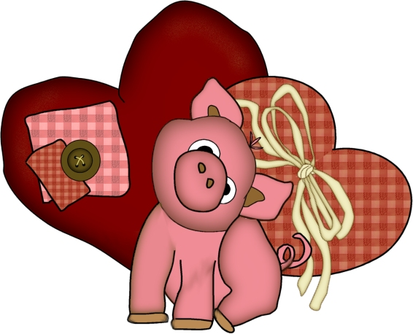

Name: _______________________________________________

Sort your fruit snack hearts into the hearts below.

I had ___ white hearts in my bag.

I had ___ red hearts in my bag.

I had ___ pink hearts in my bag.

I had ___ purple hearts in my bag.

