Sort and Graph Pumpkin and Bat Pretzels

Name _________________________________________Date:____________________

What kinds of pretzels are in your bag? Sort your pretzels by shape. Count how many you have of each shape. Write how many in the stars.

Bats | 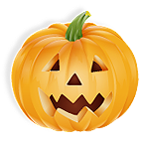  Pumpkins

Color the graph to match your pretzels!
5
4
3
2
1

Copyright @2010 Colleen Gallagher www.teachingheart.net

