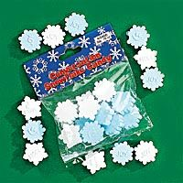Name:_____________________________ Date:____________________

DIRECTIONS: Use your snowflake candy to complete these activities.

Color in the graph to match the snowflakes in your bag.

Blue
White
Do you have more white snowflakes or blue? ______________________

How many snowflakes do you have altogether? ____________________

Each snowflake has something written on it or drawn on it. Pick 3 snowflakes and use the spaces below to write what is written on the snowflakes.

1.) ____________________________________________________________________________

2.) ____________________________________________________________________________

3.) ____________________________________________________________________________
Measure this tree with your snowflake candy.

- How many snowflakes tall is this tree? _______________
- How many snowflakes fit inside this tree? _____________

Draw 3 snowflakes in this circle. Draw 2 + 2 flakes in this circle.

Copyright 2003 by C. Gallagher @ www.teachingheart.net

