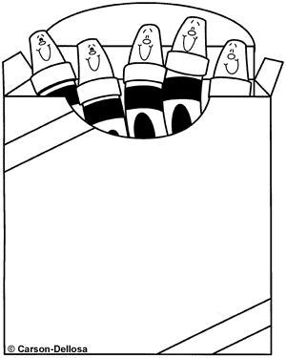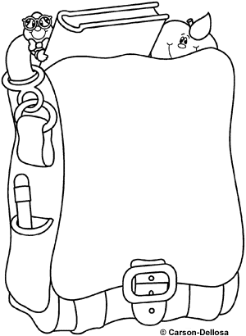
I know
my colors.
__________
I know my teacher’s name.
_________

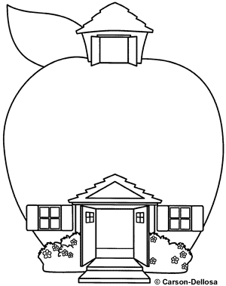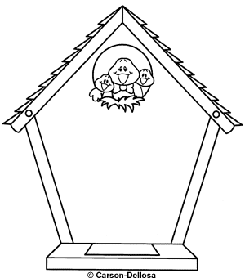
My name is
__________
I know my address.
___________

I can count to 10.

______________
I know my phone number.
______________

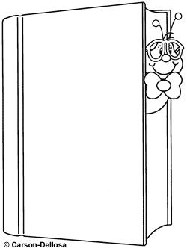
I can recognize numbers 0 to 5.
______________
I can read these words:

is, and, Is, I, said.

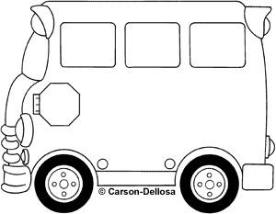
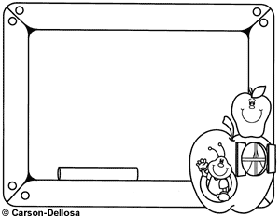
I know my shapes.

_______________
I can read these words:
a, my, that, the

______________
_

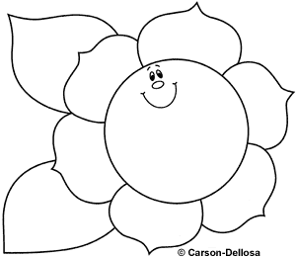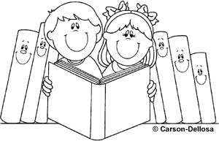
I know 10 sounds.
______________
I know 20 sounds.
_____________


I know all of my sounds!

__________________


I can count to 20.

______________
I can recognize numerals 6-10 out of sequence.

_____________


I can put numerals 0 to 10 in order.

___________________
I can read my color words.

________________

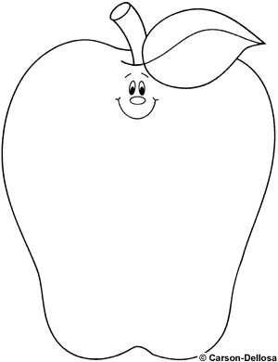
I know these words:
we, are, you, have

_________________
I know these words:
me, to, do , go

_______________

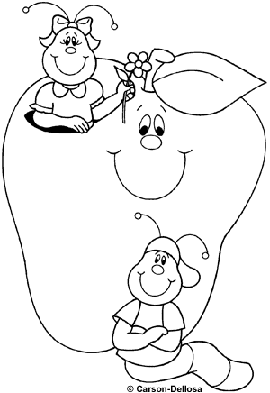
I can count to 100.

________
I know a poem or song.

____________

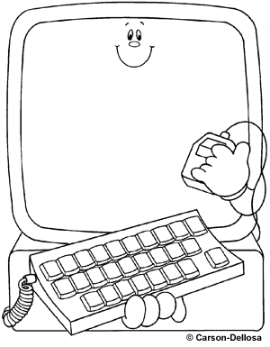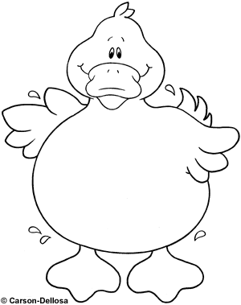
I know my numbers 11-20 out of order.

________________
I know my birthday.

________________

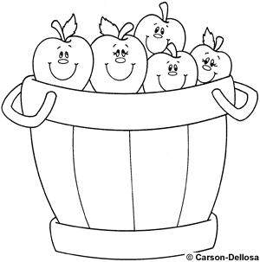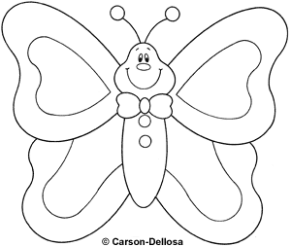
I know these words:
he, for, has, not

________________
I know these words:
she, was, of, with
_________________

Final one…print out and add the year to show completed set!!


I did it!!
__________
___________

