Name:________________________ Date:____________________________
Lucky Shamrocks

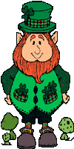
Directions: Find a friend to play with. Get dice and two crayons. Take turns rolling dice. Color in a shamrock for each number you rolled. The first person to color in all their shamrocks wins.



Who rolled the most shamrocks? _________________

Sheet Created by C. Gallagher @ http://www.teachingheart.net Copyright © 2004 - Clifford Graphic drawn by Colleen Gallagher all other Artwork Copyright © 1998-2004 Original Country Clipart by Lisa www.countryclipart.com

