Have your students place the following in a baggie or another type of container. Film containers work well.
½ cup of oatmeal
½ cup of sugar
2 tablespoons of green Christmas sugar
2 tablespoons of red Christmas glitter

Staple the graphic below to the baggie
You may choose to delete this version of the reindeer poem and supply your own or one you find on another site!
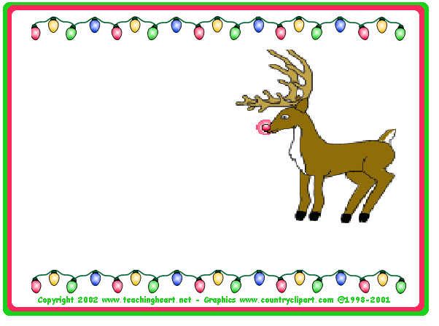
Magic Reindeer Food

On Christmas Eve sprinkle Magic Reindeer
Food on your lawn before you head
to bed. The Christmas Sugar will
sparkle when the moonlight hits it.
The shine will help Santa find your house
before the sun comes up, The smell of fresh
oats will attract the hungry bellies of the
Reindeer. No need to worry, follow this
recipe and when you wake up Santa will
have paid a visit and his reindeer will remember you forever!

