Graph Activity Sheet

Name:_____________________________________________________Date:__________________________
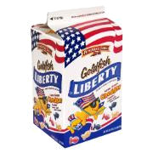
Use your crayons and color your graph.
 |  | 
Red | White | Blue | Red & White | Red& Blue | Blue & White
Answer the question based on your graph above.

1.) What color did you have the most of; red, blue, or white?________________________________

2.) What color did you have the least of; red, white, or blue?________________________________

3.) How many red goldfish did you have?___________________________________________________

4.) Circle the statement or statements that are correct:

Red & White together is more than Red & Blue together.

Red & Blue together is more than Red & White together.

There are more red than blue.

I had less than three white fish.

Copyright 2011 by Colleen Gallagher @ www.teachingheart.net

