Teacher: Print, laminate, and cut sentence strips. Print, laminate, and cut pictures. Place pictures in a basket. Place sentence strips in pocket chart. Have your students match the picture to the sentence.

I like apples big or small.
I like peaches big or small.
I like pies big or small.
I like apples in my pie.
I like peaches in my pie.
I like apples, peaches, and pies.



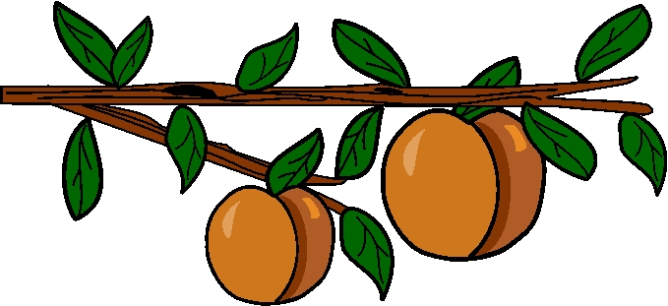



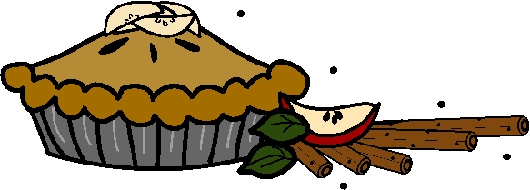 | 