PLEASE READ BEFORE USE!!!


Please read this agreement carefully before using Primary Teacher Time Savers CDROMs or Packets. By using the CDROMs or Packets, you signify your agreement to the terms in this statement. If you do not agree to these terms, please do not use the Teaching Heart’s Primary Teacher Time Savers CDROMs or Packets.

Primary Teacher Time Savers CDROM’s or Packets are only to be used for private/classroom use by the purchaser (unless you were given written permission to share this CD with another user). Teaching Heart is not selling the graphics that go along with the activities on this CD. The graphics are from Microsoft Office or Artwork Copyright © 1998-2002 Original Country Clipart by Lisa www.countryclipart.com. This is stated on each sheet.

Do not publish any part of this CD anywhere without written permission of the owner. Any violation will result in legal action and fines. All material may be accessed, downloaded, modified, and/or printed for your personal or classroom (non-commercial) use only. Without the prior written permission of Teaching Heart you may not including, but not limited to, copy the CDROM, reproduce the CDROM and it’s contents, republish the CDROM and it’s contents, upload, post, transmit, distribute in any way, or transfer any material on this CD, in whole or in part. In particular printing and creating the items on this CD and then selling them pre-made is strictly prohibited. Materials may not be reproduced on another website, book, or publication, etc... You may modify the sheets to meet your needs and the needs of your students. If you choose to modify the sheet, you must still abide by the terms above and the sheet is still considered property of Teaching Heart and Colleen Gallagher.

The contents of its CD are the sole property of Colleen Gallagher and Teaching Heart. If you are in violation of these terms you accept that you are responsible to make full restitution, pay all legal and collection cost acquired, as well as pay a $500 fine to the owners of this CD. By using the Primary Teacher Time Savers CDROM’s or Packets you represent and warrant to Colleen Gallagher and Teaching Heart that you will fully comply with these terms and conditions of use. Colleen Gallagher or Teaching Heart may modify this agreement at any time, and such modifications shall be effective immediately upon posting of the modified agreement to the Teaching Heart Website.

Thank you for your cooperation in following this copyright and terms notice. If you have any questions about this notice please email us: teachingheart@teachingheart.net

Sheet Copyright @ 2002-2011 C. Gallagher www.teachingheart.net

The St. Patrick's Day Packet
Great Thematic Activities For Your St. Patrick's Day Unit
All sheets are in Word and can be modified to meet your needs.
(Grades K-3)
Improved in 2011!!!
1.) Graphing the St. Patrick's Way- (1-2) (FREE TO DOWNLOAD)
Your students cut out various St. Patrick's Day Pictures. They then place those pictures on their graph. After the pictures are on the graph, they answer questions about the graph.
~This activity will not be found on our CDROMS
2.) Leprechaun Erase a Rhyme Activity - (k-2)
This is three sheets. The first sheet is teacher directions. The second sheet is an easy to draw graphic of leprechaun. (The students may also keep this at their seats and cross out the parts as you work the lesson with the class.) The third sheet is an independent activity for your students to complete after the lesson.
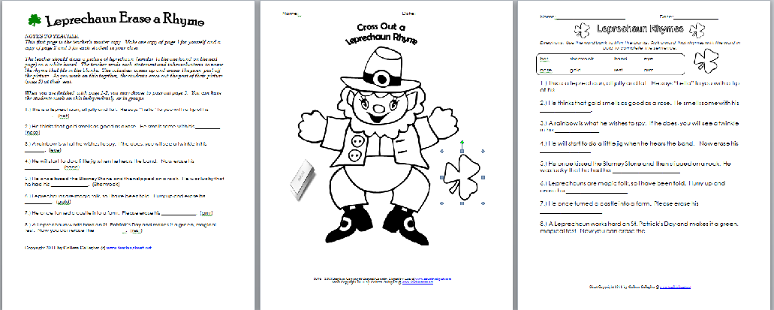
3.) Mini Book- (k-2)
Your student is given various pictures to color and then cut. They place these pictures on the correct pages of the given book! A very cute book!
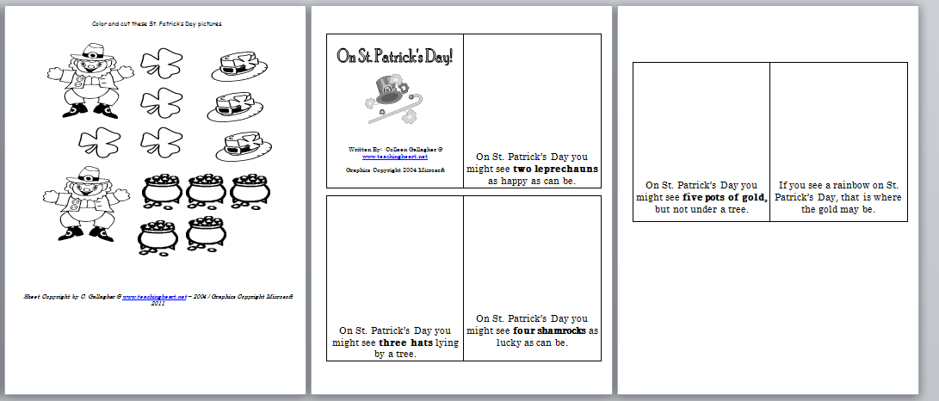
4.) Roll For St. Patrick's Day (k-2)
A gameboard for a dice game.
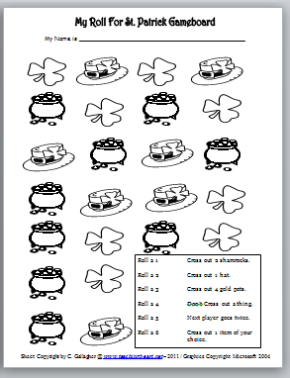
5.) Leprechaun Word Building -(1-2)
Includes the letters in the word Leprechaun for your students to cut & use. They must then use the letters to form words and answer questions. This also makes a great word building center!
6.) St. Patrick's Day Following Directions Activity (k-2)-
Student read directions and completes various activities. These directions can be read by the teacher (listening comprehension) or the student (reading comprehension).
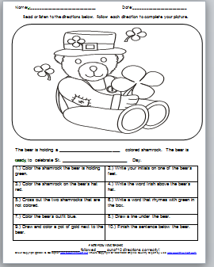
7.) A Little Color Green Book (k-2) (Click to download for free)
A fill in the blank book for your students to complete.
~This activity will not be found on our CDROMS
8.) Pocket Chart Fill in The Blank (k-2)
Materials for your pocket chart. All you need to do is print, laminate, and cut. You can use this as a group activity (k-1) or as an independent center (1-2). Includes a center sheet for your student to complete after they finish the center. Students must find the picture that fits in the blank.
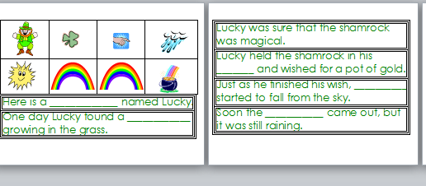
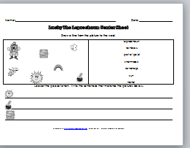
9.) Letters In Leprechaun Activity Sheet (1-2)
Student finds words that start with the letters in the word Leprechaun. They organize their words on this sheet.
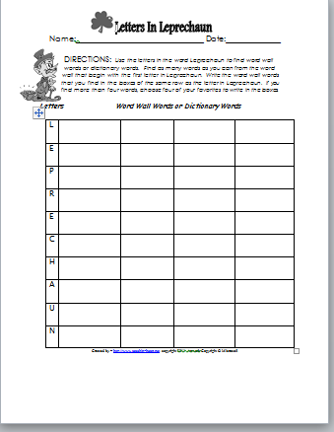
10.) Shamrock Shopping Activity Sheet(1-2)
St. Patrick's Day Words are given. Each letter has a value. Students must add up the letters to find a total cost of a given word.
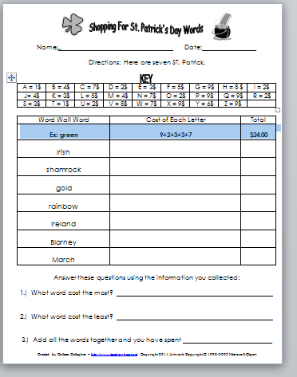
11.) Shamrocks Count By 5's Envelope Center (k-1)
Print, laminate, and cut a few of these sets. Place ach set in an envelope or baggie. The students must place these in the correct order.
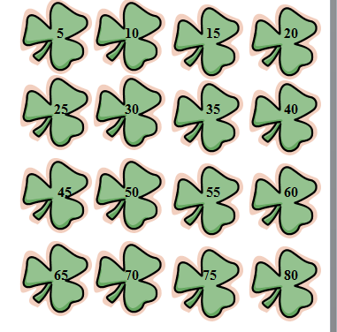
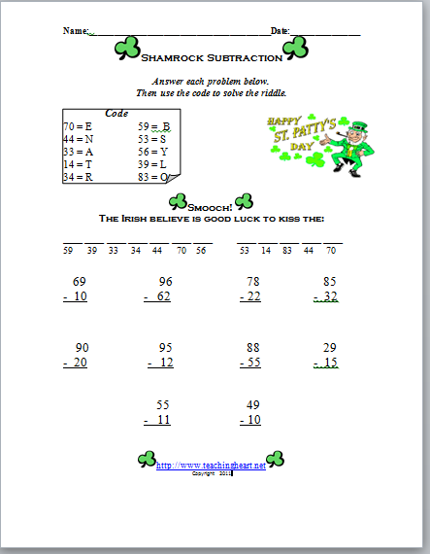
12.) Sorting St. Patrick's Day Shapes (k-1)
Student cuts out various ST. Pat's day graphics and glues them to a sorting sheet.
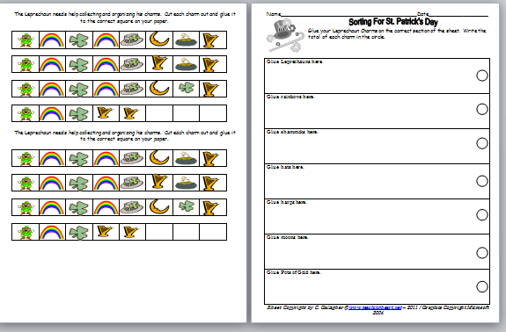

13.) Shamrock Subtraction (2-3)
Students answer Subtraction Problems and find the mystery!

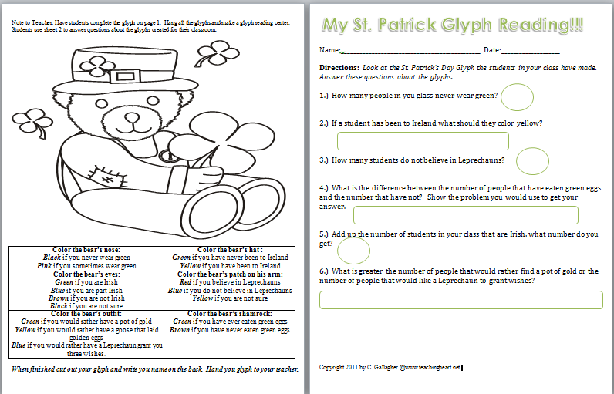
13.) Pot of Gold Graph Reading (1-3)
Students read graph and answer questions.

14.) Glyph Center
Students make a Glyph and then teacher hangs the Glyphs and students complete the center sheet.

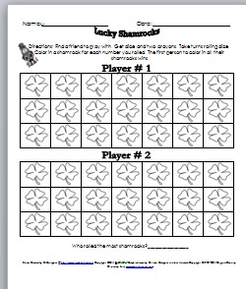
15.) St. Patrick’s Day Dice Game (k-1)
Two player game. Board included. Teacher Supply Dice!

Over 25 sheets of printables for only 14.99!
Instant Download after you complete Paypal! You will be emailed a link to download your packet.

http://www.teachingheart.net/stpatpacket.html

