Old Lady Who Swallowed a Shell Vocab. Cards
shell | Crab
Fish | Gull
Pail 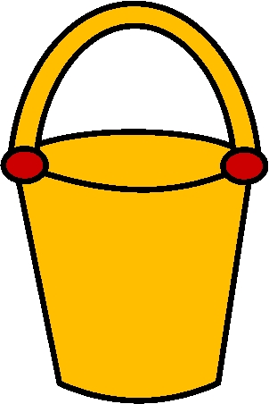 | Sand 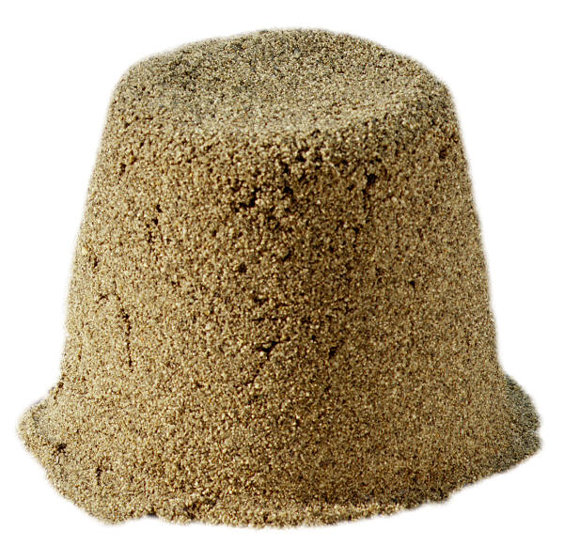
Wave | sandcastle

