Name:______________________________________________ Date:________________________________

Today we read There was an Old Lady Who Swallowed A Shell by Lucille Colandro. Fill in the blanks with what the old lady swallowed and draw the object in her hands.

Words to use: sandcastle, pail, sand, crab, gull, fish, & shell
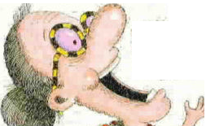  There was an old lady who swallowed a  ____________. | There was an old lady who swallowed a  ____________.
There was an old lady who swallowed a  ____________. | There was an old lady who swallowed a  ____________.
There was an old lady who swallowed a  ____________. | There was an old lady who swallowed some  ____________.

Sheet Copyright 2006 C. Gallagher @ www.teachingheart.net

There was an old lady who swallowed a  ____________. | She burped and built a  _____________________________

