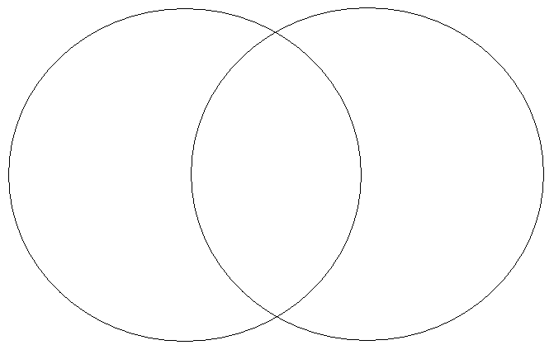

The Hat
The Mitten

Copyright 2002 C. Gallagher Teaching is a Work of Heart www.teachingheart.net

