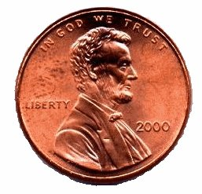
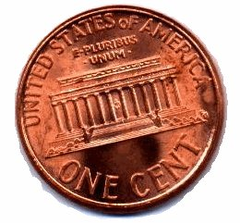
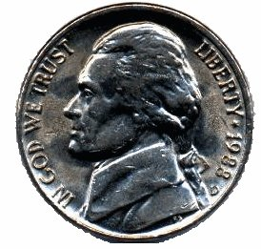
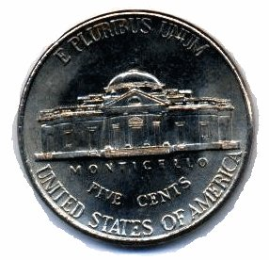
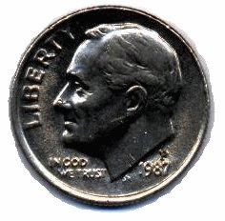
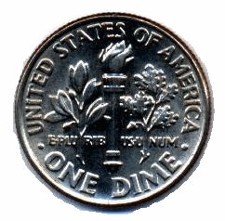
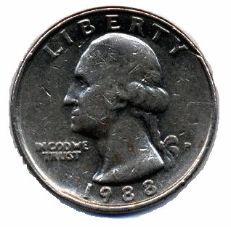
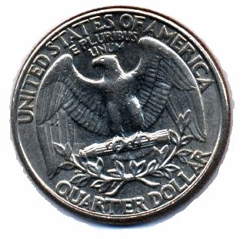
Shapes

circle
square
triangle
rectangle

pentagon

hexagon

octagon
parallelogram

trapezoid
cylinder
cube
rectangular
solid
right
triangle
= penny = 1 c

(one cent)
= nickel = 5 c

(five cents)
= dime = 10 c

(ten cents)
= quarter = 25 c

(twenty-five cents)

Money
Order Words

first

second

third

fourth

fifth

sixth

seventh

eighth

ninth

tenth

Blythe Academy of Languages
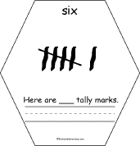 | 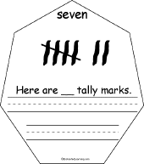 | 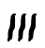 | 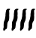 | 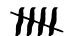 |  |  | 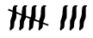 | 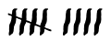 | 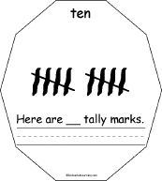
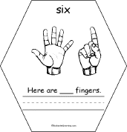 | 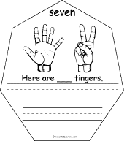 | 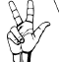 | 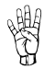 | 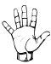 |  |  | 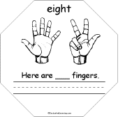 | 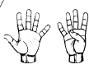 | 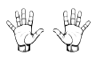
1 | 2 | 3 | 4 | 5 | 6 | 7 | 8 | 9 | 10
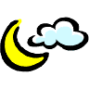
Numbers

0 = zero (cero)
1 = one (uno)
2 = two (dos)
3 = three (tres)
4 = four (cuatro)
5 = five (cinco)
6 = six (seis)
7 = seven (siete)
8 = eight (ocho)
9 = nine (nueve)
10 = ten (diez)
11 = eleven (once)
12 = twleve (doce)
13 = thirteen (trece)
14 = fourteen (catorce)
15 = fifteen (quince)
16 = sixteen (dieciseis)
17 = seventeen (diecisiete)
18 = eighteen (dieciocho)
19 = nineteen (diecinueve)
20 = twenty (veinte)
30 = thirty (treinta)
40 = forty (cuarenta)
50 = fifty (cincuenta)
60 = sixty (sesenta)
70 = seventy (setenta)
80 = eighty (ochenta)
90 = ninety (noventa)
100= one-hundred (cien)



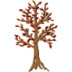



spring
summer
winter
autumn
(fall)
12:00 am
MIDNIGHT
12:00 pm
NOON
1 | 2 | 3 | 4 | 5 | 6 | 7 | 8 | 9 | 10
11 | 12 | 13 | 14 | 15 | 16 | 17 | 18 | 19 | 20
21 | 22 | 23 | 24 | 25 | 26 | 27 | 28 | 29 | 30
31 | 32 | 33 | 34 | 35 | 36 | 37 | 38 | 39 | 40
41 | 42 | 43 | 44 | 45 | 46 | 47 | 48 | 49 | 50
51 | 52 | 53 | 54 | 55 | 56 | 57 | 58 | 59 | 60
61 | 62 | 63 | 64 | 65 | 66 | 67 | 68 | 69 | 70
71 | 72 | 73 | 74 | 75 | 76 | 77 | 78 | 79 | 80
81 | 82 | 83 | 84 | 85 | 86 | 87 | 88 | 89 | 90
91 | 92 | 93 | 94 | 95 | 96 | 97 | 98 | 99 | 100

Number Chart
ABCDEFGHIJKLMNOPQRSTUVWXYZ

- Sunday (domingo)
- Monday (lunes)
- Tuesday (martes)
- Wednesday (miercoles)
- Thursday (nueves)
- Friday (viernes)
- Saturday (sabado)

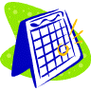
red
rojo

orange
anaranjado

yellow
amarillo

1st = January (enero) 7th = July (julio)
2nd = February (febrero) 8th = August (agosto)
3rd = March (marzo) 9th = September (septiembre)
4th = April (abril) 10th = October (octubre)
5th = May (mayo) 11th = November (noviembre)
6th = June (junio) 12th = December (diciembre)

green
verde

blue
azul

purple
morado

pink
rosado
United States of America
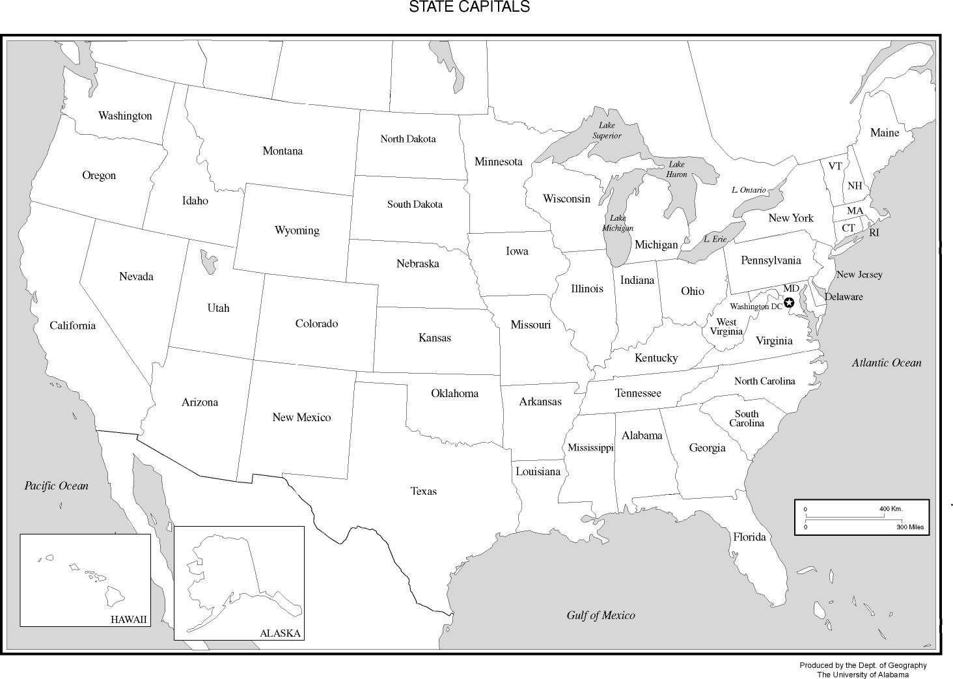
gray
gris

brown
cafe

black
negro

white
blanco

Where I Live

Planet
Earth
Continent
North America
Country
USA
State
South Carolina
County
Greenville
City
Greenville

