

Name:____________________________

Cut and glue the correct number to match each set.

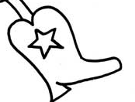

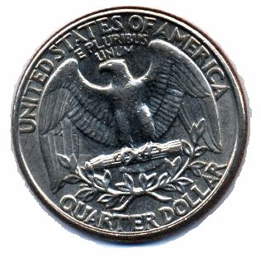
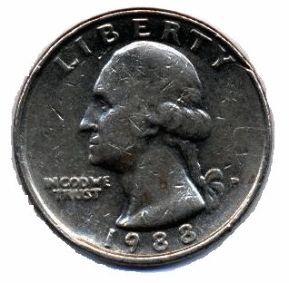
RL - 2005

-------------------------------------------------------
1 | 2 | 3 | 4 | 5

