Roll & Color The Cat's Stripes!

Copyright 2003 @ www.teachingheart.net

Names: ______________________________ (GREEN) ___________________________________ (RED)
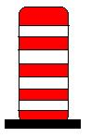

How many red striped hats?___________

How many green striped hats? ________

