NAME:_________________________________ Date:_______________________________

Graphing Halloween Fruit Snacks
Color in the graph to match the gummy candy in your bag. Answer the questions on the back of your graph.
9
8
7
6
5
4
3
2
1
 | 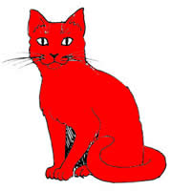  Red Cat | 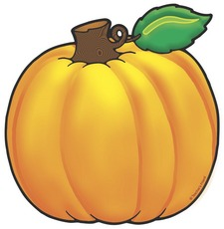  Orange Pumpkin | 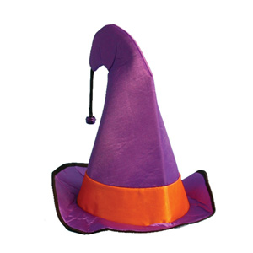Purple Witch Hat |   Yellow Ghost | 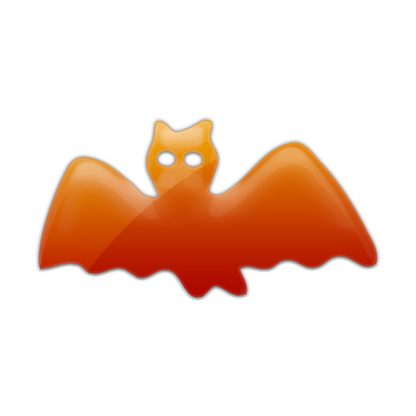Red Bat | Green Spider

Sheet Copyright C. Gallagher 2010 - www.teachingheart.net

DIRECTIONS: Use your finished graph to answer these questions.

1.) How many cats were in your  bag?  _____________ cats | 2,) How many pumpkins were in your  bag??  _____________ pumpkins
3.) How many witches hats were in your bag?  _____________ witch | 4,) How many ghosts were in your  bag??  _____________ ghosts
5.) How many bats were in your  bag?  _____________bats | 6.) What gummy did you have the most of? Circle your answer.
5.) How many spiders and ghosts did you have altogether?  _____________spiders and ghosts | 6.) Did you have more witch hats or more cats?  I had more________________

Look at your neighbors graph to answer these questions.

7.) My neighbor’s name is _________________.  My neighbor’s graph shows that he/she had  ______ spiders and _______ pumpkins. | 8.) I had more ______________ in my bag than  my neighbor did. My neighbor had more  _______________ than I did.

