Note To Teacher: Below are two pages for your students. Print page 2 on a separate sheet of paper. Copy page 3 and 4 front to back. Cut out a few of the Halloween pictures and show your students how to place them on the graph. Then, allow them to complete the rest. When they are finished, instruct them to complete the graph questions on the back of page the graph.

Fall is here! Let’s graph the Halloween objects. Cut each object out and glue it to the correct space on the graph.

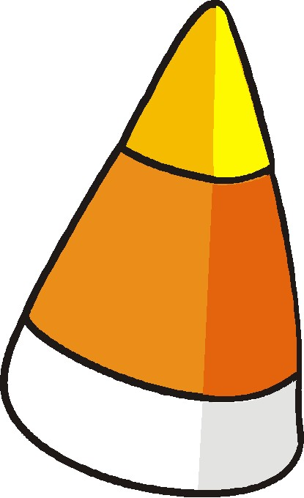 | 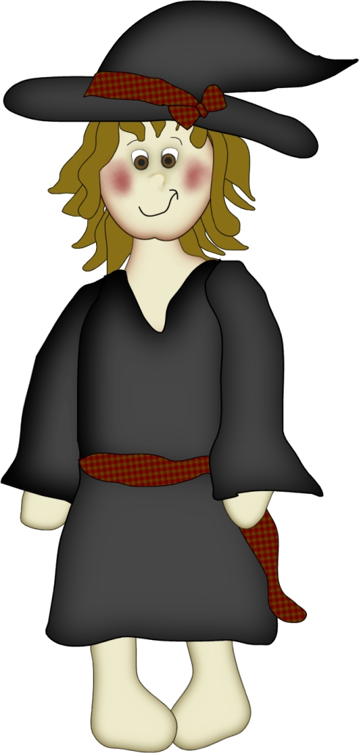 |  |  | 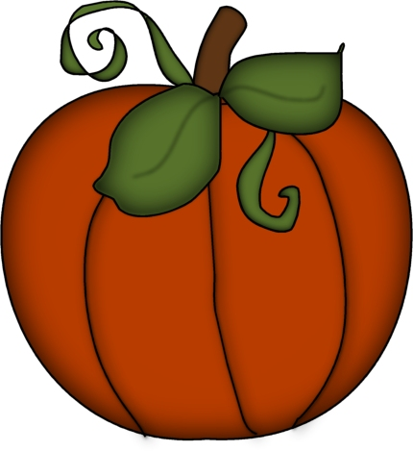

Name:________________________ Date________________________

Glue your Halloween Pictures on the correct section of the graph. Answer the questions about your graph.
Graphing For Halloween

Candy Corn

Ghost

Black Cat
Pumpkin

Witch
Scarecrow

Cupcake

Turn Over Your Paper and Answer the questions about your graph!

Answer These Questions about your graph!

1.) What kind of Halloween pictures do you have the most of? _____________________________________

2.) What kind of Halloween pictures do you have the least of? ______________________________________

3.) Do you have more scarecrow pictures or more ghost pictures? ___________________________________

4.) How many more candy corn pictures than pumpkin pictures do you have? _________________________

5.) How many pumpkins, scarecrows, and cats do you have altogether?

___________________________________________________________________________________________

6.) Do you have more cupcake pictures or more witch pictures? ____________________________________

7.) What two pictures do you have the same number of? __________________________________________

8.) Draw the four pumpkins.

9.) Does your picture of fewer or greater pumpkins than your graph? ________________________________

10.) Draw eights ghosts.

11.) Does your picture have fewer or greater ghosts than your graph?_________________________________

Sheet Copyright by C. Gallagher @ www.teachingheart.net – 2009 / Graphics Copyright 1998 - 2003 Original Country Clipart by Lisa @ www.countryclipart.com

