NAME:_________________________________ Date:_______________________________

Sorting Gummy Bears and Scares

Take your gummy candies out of the bag and place them in the correct rectangle. Count your gummy candies and write the number you have of each.
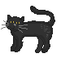  Purple Cat  I have ______  purple cats. | Orange Pumpkin  I have ______  orange  pumpkins. |   Purple Witch  I have ______  purple  witches. |   White Ghost  I have ______  white ghosts. | 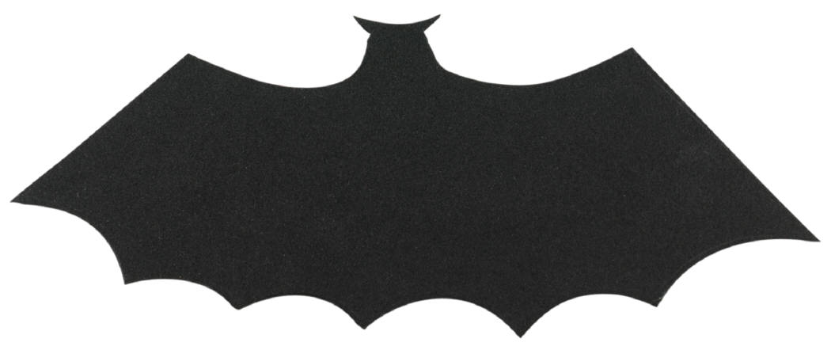  Purple Bat  I have ______  purple bats.

Circle the gummy you have the most of and place a line under the gummy you have the least of.
 Sheet Copyright www.teachingheart.net

