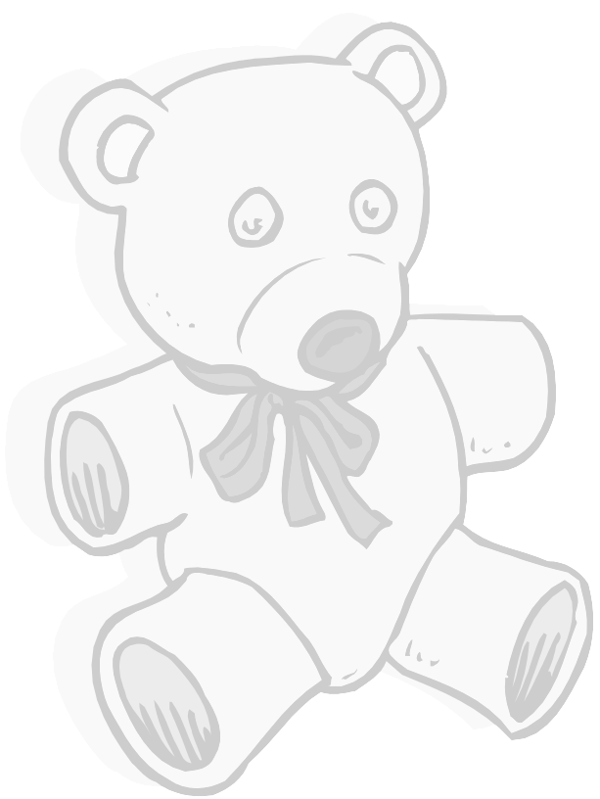
My Gummi Bear Graph

Directions: Your Teacher will give you a baggie with 12 Gummy Bears in it. Don’t eat them yet. Color the graph to match the bears in your bag.

Name of Graph Maker ____________________________________
red | green | yellow | orange
Now trade graphs with a friend. Your friend will answer the questions about your graph.

Name of Graph Reader:__________________________________________________________________

1.) What color of Gummi Bears did your friend have the most of? ___________________

2.) What color did your friend have the least of? ___________________________________

3.) Did your friend have more yellow or more green Gummi Bears? _________________

4.) How many red and orange Gummi Bears did your friend have altogether? ______

5.) What is greater, the number of green bears or the number of red bears? ________

6.) Subtract the number of red bears from the yellow bears and you get? ___________

Copyright 2003 Teaching is a Work of Heart www.teachingheart.net

