Wake Up Groundhog!

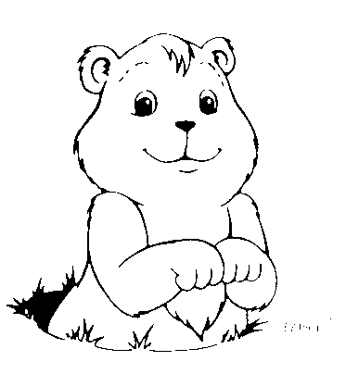

Oh no!
Six more
weeks of
winter!

Wake up!
See the shadow.

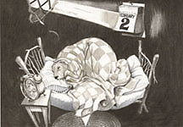

Wake up!
Groundhog!

Wake up!

See the grass.

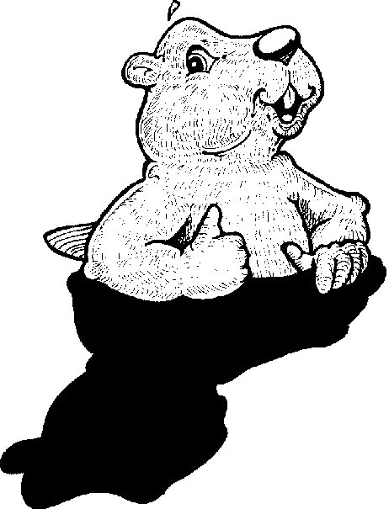

Wake up!
See the sun.

Wake up!
See the sky.

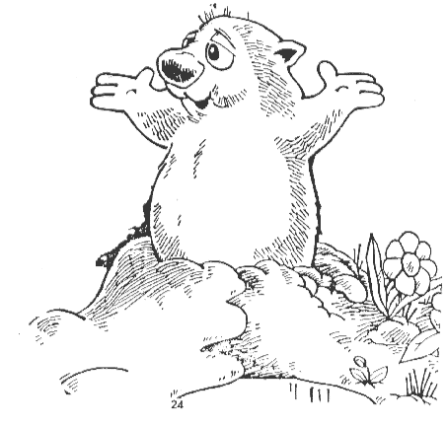

Wake up !
See the flowers.

Wake up!

See the birds!

Wake up!
See the trees.

