Note To Teacher: Make this spinner by printing, laminating, and cutting. Then use a paper fastener in the center as the spinner. Student spins ten times and colors in the graph to match their spins.

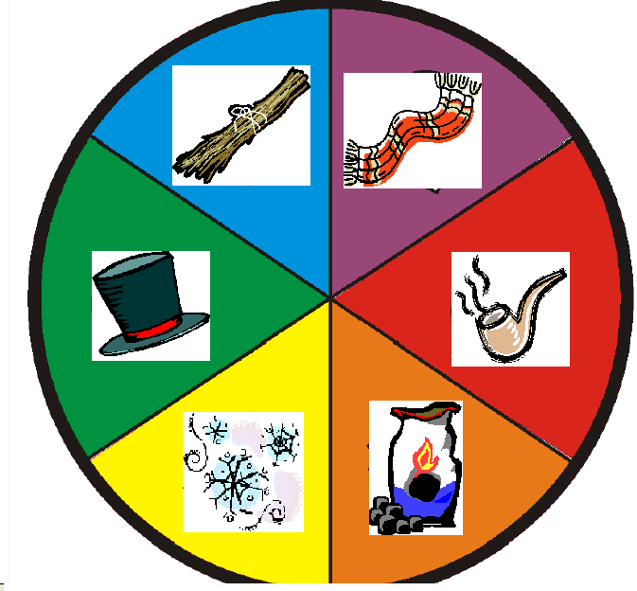

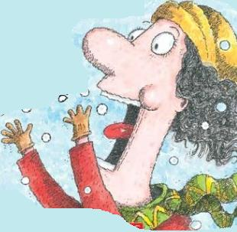

Name:_______________________________________ Date:_____________________________

Directions: Spin your spinner 10 times. After each spin color in the section of the graph that matches your spin.

10
9
8
7
6
5
4
3
2
1
 | Snow | Pipe | Coal | Hat | Stick | Scarf

Questions about your graph:

1.) What object did you spin the most of? ____________________________________________________

2.) What object did you spin the least of? ____________________________________________________

3.) How many times did you spin coal? _______________________________________________________

4.) How many times did you spin snow? ______________________________________________________

Sheet Copyright C. Gallagher www.teachingheart.net

