Note To Teacher:

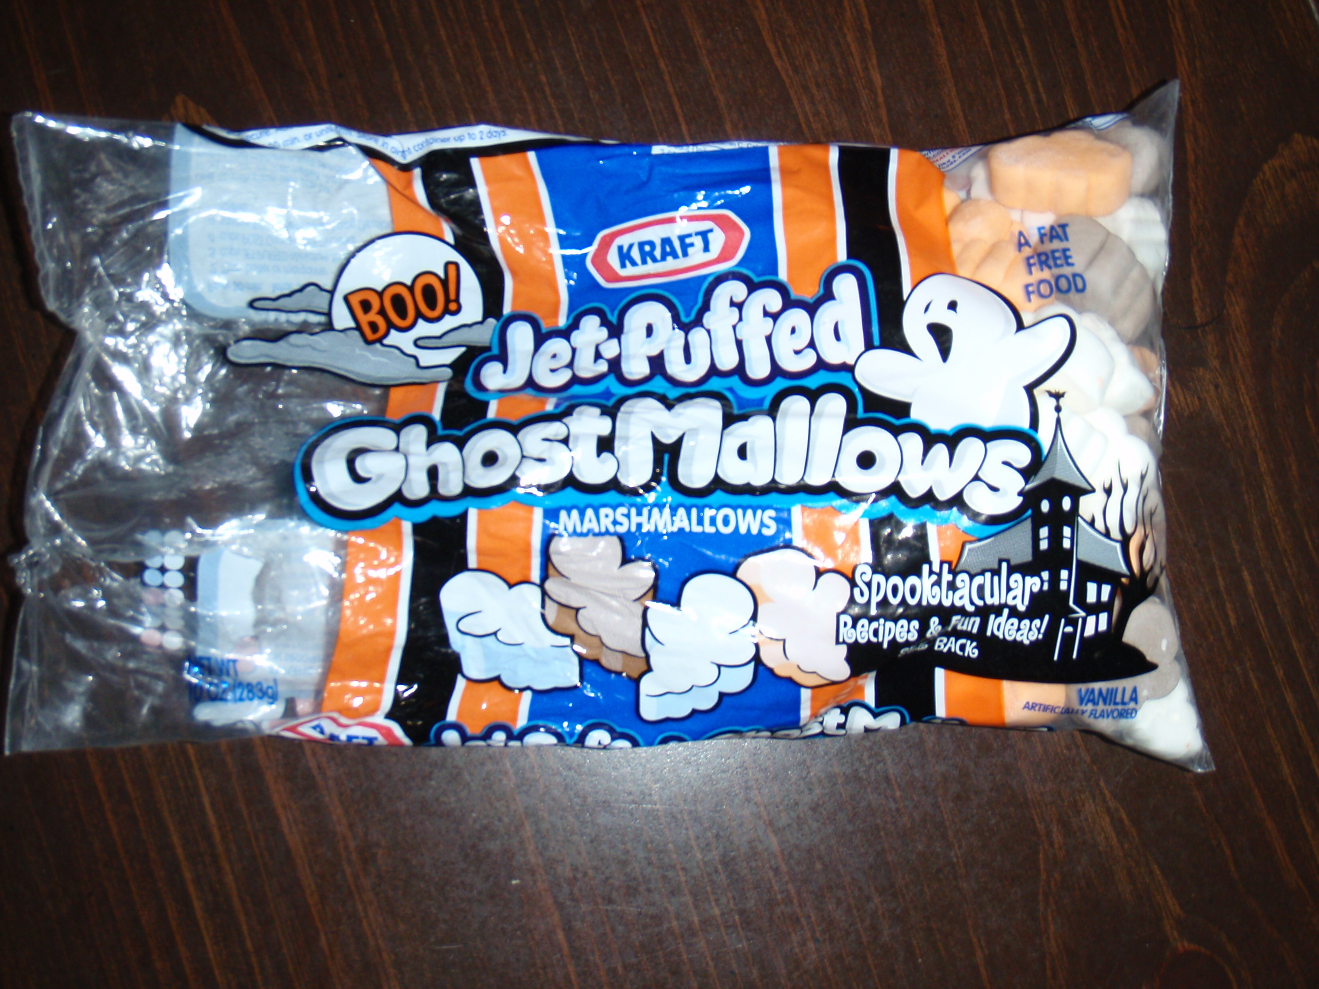
Use the Jet-Puffed Ghost Mallows to complete these math activities.

ACTIVITY 1: SORTING AND GRAPHING SHEET: Purchase Jet-Puffed Ghost Mallows at your local store during the fall season. Place a few in a cup for each student. First have the students sort their ghosts, next have them complete the graph.

ACTIVITY 2: Ghost EQUATIONS: Split students into groups of two. Supply each team 12 ghot in a cup and 1 dice. Each student should complete their own ghost equation sheet (page 4).
The first student rolls the die, and counts out that many marshmallow ghosts. Each student writes the number on his/her equation sheet. Then the second student rolls the die and counts out that many ghosts. Each child writes that number on his/her equation sheet. The plus sign and equal sign are already on the sheet. Then they combine their marshmallow ghosts to see how many they have in all. Last, they record their answer. After putting the ghosts back in their cup they follow the same procedure to write their next equation. Each pair of students needs to do five equations. Then they work together to read & complete the tasks below the equations.

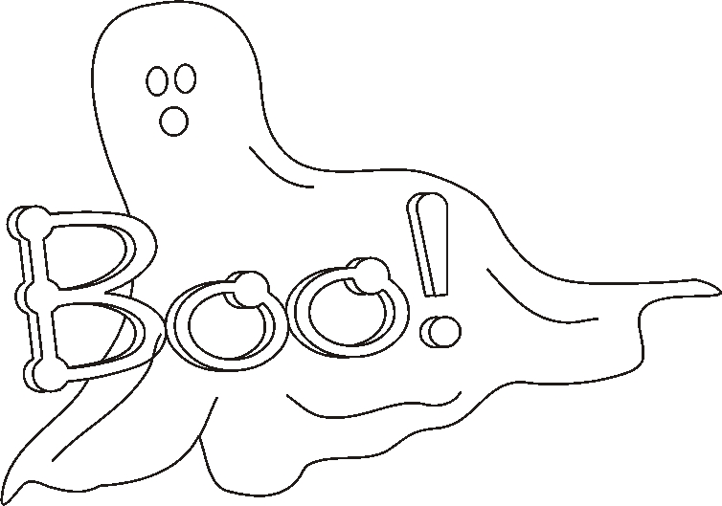
Name:______________________________________ Date:_________________________
Sort your marshmallow ghosts into the correct box. Count each set of stars and write the total of each color in the circle.

Brown | White
Orange | Color
Name:___________________________________________ Date:____________________
Color Your Graph!
Graphing Your Ghosts!

Orange
Ghosts

Brown
Ghosts

White
Ghosts

Answer these questions about your graph!

1.) What color ghosts do you have the most of? _____________________________________

2.) What color ghosts do you have the least of? _____________________________________

3.) Do you have more orange or brown ghosts? _____________________________________

4.) Do you have more white or orange ghosts? ______________________________________

5.) How many orange ghosts do you have?_________________________________________

6.) How many brown ghosts do you have? _________________________________________

7.) Add your orange and brown ghosts together and you get a sum of ___________________

8.) Add all of your ghosts together. How many do you have altogether? ________________

Ghost Equations
Names of Ghost Mathematicians ____________________________________

_____ + _____ =
_____ + _____ =
_____ + _____ =
_____ + _____ =
_____ + _____ =

1.) Add up all the numbers in your circles and you get ______________________________________

2.) Color the box with the greatest sum yellow.

3.) Color the box with the smallest sum pink.

4.) Place equal number of ghosts in the boxes below. Each box should have the same amount of ghosts in it.
Now that your ghosts are split evenly, one person eats one half and the other person eats the other half.

