Name:________________________________ Date:____________________
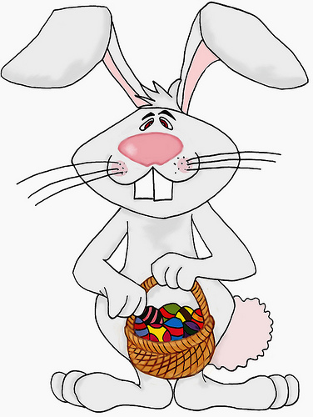
Sort each shape in the correct box. Then count your shapes and write the number of each shape in the circle.

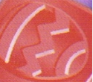  Red Egg  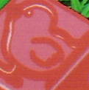 | 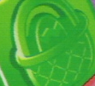  Green Basket
Red Chick | 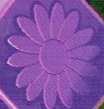  Purple Flower
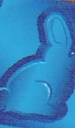  Blue Bunny | 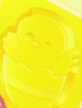  Yellow Chick

Sheet Created by C. Gallagher @ http://www.teachingheart.net Copyright © 2004 -

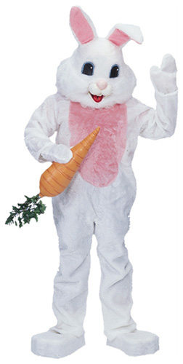

Directions: Color a square for each piece that you have. Then answer the questions about your graph.
6
5
4
3
2
1
0
 | Red Chick | Green Basket | Red  Egg | Blue Bunny | Purple Flower | Yellow  Chick

1.) How many red chick pieces do you have? ___________________________

2.) Do you have more red chick pieces or more blue bunny pieces? ______

3.) What do you have the most of? _____________________________________

4.) What do you have the least of?______________________________________

5.) Do you have more flower pieces or more chick pieces? ______________

6.) How many pieces do you have altogether? __________________________

7.) If you ate 1 basket, how many would you have left? _________________

8.) If you ate 1 egg, how many would you have left?____________________

9.) If a friend gave you two bunny pieces, how many bunnies would you have total? ____________________________________________________________

