Hum it –  Like a Prayer | Hum it –  Come on Ilene
Draw Freddy Krueger  - You may give the verbal Hint…  An 80’s Icon | Draw a Banana Clip  - You may give the verbal hint…  80’s Fashion
Charades: Jelly Shoes  -You may give the verbal hint…  80’s Fashion | Charades: The Breakfast Club  – You may give the verbal hint…  80’s Movie Hit
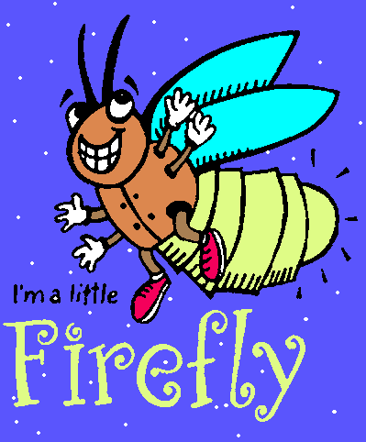

80’s Quotes!

"Dong, where's my automobile?"
Back to the Future
Sixteen Candles
Spaceballs
Twins
E.T.
Princess Bride

"I feel the need, the need for speed"
a.) Back to the Future b.)Batman c.)Top Gun d.) Short Circuit

You just bought yourself another Saturday"
Big
Lucas
Footloose
The Breakfast Club
Sixteen Candles
Summer School

NAME THESE TOYS:
A. B. C.
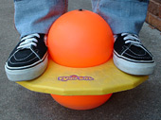
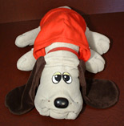
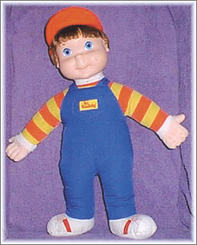

Name These Toys

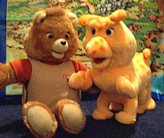
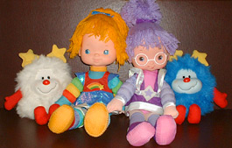
A. 