Pull a question out of the hat… If it is a discussion question, read aloud for all to discuss. If it is a challenge question, read it and either do what is said on the card or pass it to someone else to complete. Goal is to get the most number of fireflies.

1.)  CHALLENGE: For 1 Firefly
Answer the question:
Tell us about your best friend as a child. What you did together, how you met, and why you were friends with this person.

2.) CHALLENGE: For 2 Fireflies & 1 For a friend
Pick a friend in the room that you think can help you name that 80’s Tune. If one of you names it correctly, your friend gets one firefly and you get two. If they can’t name that 80’s tune – no Fireflies.

3.) CHALLENGE: For 1 Firefly
Listen to a quote from an 80’s movie. Pick the movie the quote came from.

4.) CHALLENGE: For 1 Firefly
Listen to a quote from an 80’s movie. Pick the movie the quote came from.

5.) CHALLENGE: For 1 Firefly
Listen to a quote from an 80’s movie. Pick the movie the quote came from.

6.) CHALLENGE: For 2 Fireflies & 1 For a Friend
Pick a friend in the room that you think can help you name that 80’s Tune. If one of you names it correctly, your friend gets one firefly and you get two. If they can’t name that 80’s tune – no Fireflies.

7.) CHALLENGE: For 2 Fireflies & 1 For a Friend
Pick a friend in the room that you think can help you name that 80’s Tune. If they one of you names it correctly, your friend gets one firefly and you get two. If they can’t name that 80’s tune – no Fireflies.

8.) CHALLENGE: Name that toy! For Up to three fireflies!
You will see a picture of three toys from the 80’s. For each one you name correctly, you get a Firefly. If you miss one, pick one person to try and guess what it is and they could win a firefly.

9.) CHALLENGE: Name that toy! For Up to three fireflies!
You will see a picture of three toys from the 80’s. For each one you name correctly, you get a Firefly. If you miss one, pick one person to try and guess what it is and they could win a firefly.

10.) 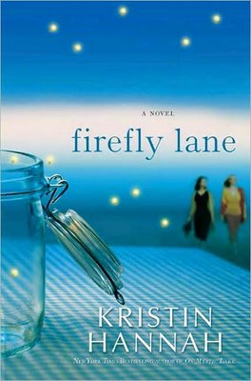QUESTION: From her earliest memory, Tully feels abandoned by her mother and father. How does this sense of being unwanted influence her life? How does her troubled relationship with her mother lead to the decisions she makes in her life?

11.) QUESTION: Do children have an obligation of some kind to forgive their parents, even inthe face of repeated disappointment? How much do you think childhood heartaches make us who we are?

12.) CHALLENGE: For 1 Firefly
Answer the question:
What qualities do you look for in a friend? What makes a good friend?

13.) CHALLENGE: For 1 Firefly
Try and trick us. Tell us two facts about yourself and one lie. Then pick on person to guess which one is the lie, if they guess correctly you loose and they win a firefly. If you stump them, you win a firefly. You have 1 min. to think and then you must tell us two facts and one lie.

14.) QUESTION: The Kate-Johnny-Tully triangle is one of the fundamental underpinnings of the novel. How does Johnny really feel about Tully? How does Tully feel about him?

15.) QUESTION: Kate believes she is Johnny's second choice for love. How does Johnny contribute to her insecurities? How did Tully? How much of a relationshipis set in the beginning and how are changes made as we grow?

16.) QUESTION: When Chad leaves Tully, she rationalizes away her broken heart by saying,"if really loved me, he would wait for me." What does this reveal about Tully's perception of romantic love? How do these perceptions setthe stage for the rest of her life? Do you believe that Tully will ever fall in love?

17.) QUESTION: Near the end of the novel, when their friend is on the rocks, both women feel wronged. Certainly Kate has ample reason to feel betrayed, but what about Tully's similar belief? Do you understand why Tully was upset, too?

18.) QUESTION: Do you believe that a friend should always reach out, even when great pain has been caused? Or do you believe that true friends would never hurt each other?

19.) QUESTION: Music plays an important role in this novel. What musical memories do you have of your teen years, your twenties, and today? Do you feel, as we get older, that music plays less of a role in our lives? Why do you feel that music so profoundly affects us when we are "coming of age?"

20.) QUESTION: What do you feel Kate was most jealous about with regards to Tully? And what was Tully the most envious of in Kate's life? Jealousy is often wanting what we cannot have. Do you feel that these characters truly could not have the things they wanted? If not, why not?

21.) QUESTION: What role do you see Tully playing in Mara's life, after the pages of the novel are closed?

22.) CHALLENGE: Draw It: A chance for 2 Fireflies & one for a friend.
See if you can get us all to guess what you are drawing. You cannot say anything or use words in your drawing. You have 2min. to get someone to guess this… If someone guesses, you get 2 fireflies & the person who guessed correctly first gets one.

23.) CHALLENGE: Draw It: A chance for 2 Fireflies & one for a friend.
See if you can get us all to guess what you are drawing. You cannot say anything or use words in your drawing. You have 2min. to get someone to guess this… If someone guesses, you get 2 fireflies & the person who guessed correctly first gets one.

24. CHALLENGE: Charades: A chance for 2 Fireflies & one for a friend.
Played like regular charades. You have two minutes to get the group to guess. If someone guesses, you get 2 fireflies & the person who guessed correctly first gets one.

25. CHALLENGE: Charades: A chance for 2 Fireflies & one for a friend.
Played like regular charades. You have two minutes to get the group to guess. If someone guesses, you get 2 fireflies & the person who guessed correctly first gets one.

26.) CHALLENGE: Hum it: A chance for 2 fireflies & one for a friend
You will be given a song from the 80’s to hum. You have 1 min. to get the group to guess your song. If someone guesses, you get 2 fireflies & the person who guessed correctly first gets one.

27.) CHALLENGE: Hum it: A chance for 2 fireflies & one for a friend
You will be given a song from the 80’s to hum. You have 1 min. to get the group to guess your song. If someone guesses, you get 2 fireflies & the person who guessed correctly first gets one.

28.) CHALLENGE: Answer it right! 1 firefly for each answer you get correct. If you cannot answer it correctly, pass it on to a friend that thinks they may know.

- What state did this story take place in?
- What was the name of the Island that Kate lived on once she was married?
- Name a Seattle Landmark.

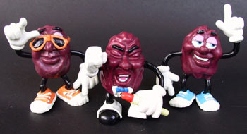
California Raisins
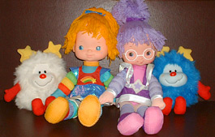

Rainbow Brite Dolls

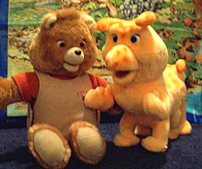

Teddy Ruxpin

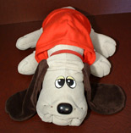

Pound Puppies

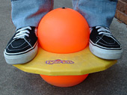

Pogo Ball

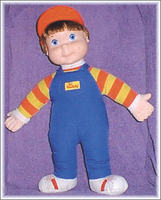
My Buddy

