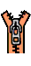
Alphabet  Chart |  | Aa  apple | Bb  butterfly
Cc  cat | Dd  duck | Ee  evergreen | Ff  fish
Gg  goat | Hh  hat | Ii  igloo | Jj  jar
Kk  key | Ll  leaf | Mm  moon | Nn  numbers
Oo  octopus | Pp  pig | Qq  queen | Rr  rabbit
Ss  sun | Tt  telephone | Uu  umbrella | Vv  vacuum
Ww  watermelon | Xx  x-ray | Yy  Yo-yo | Zz  zebra

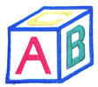
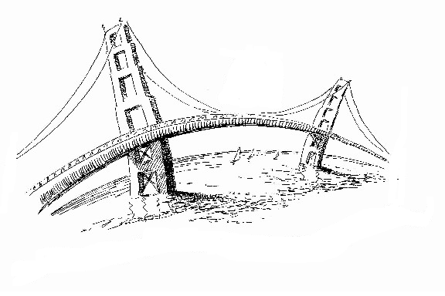
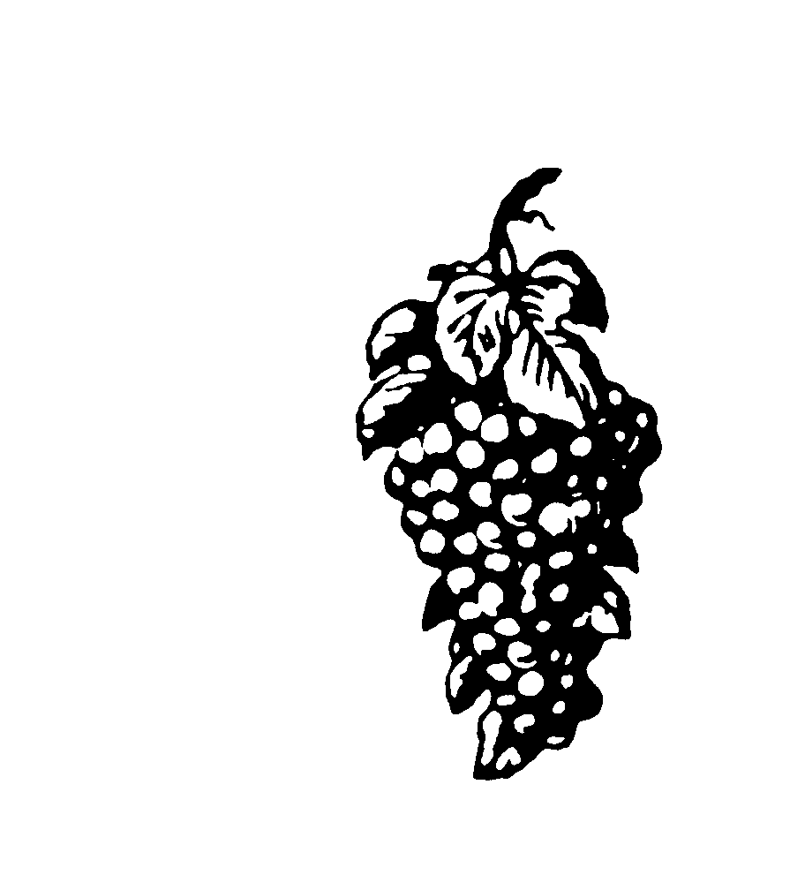
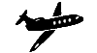
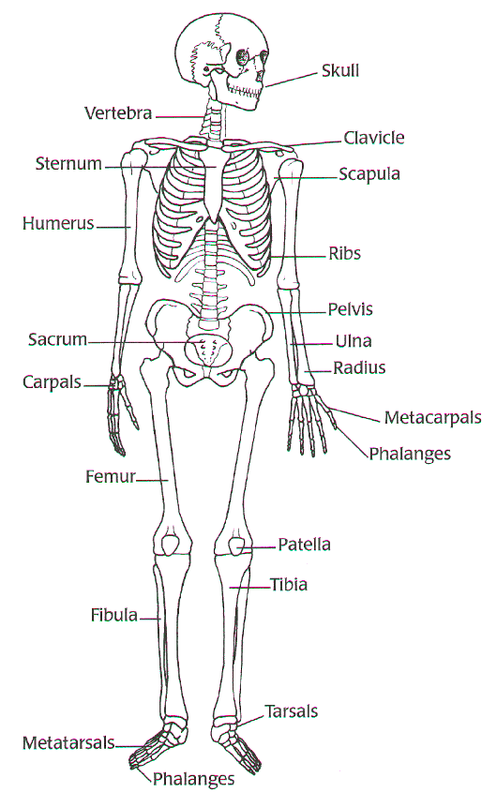
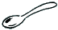
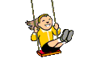
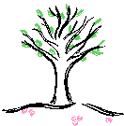
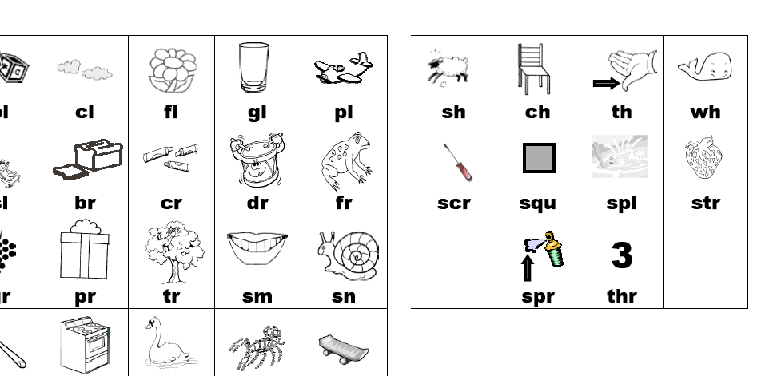
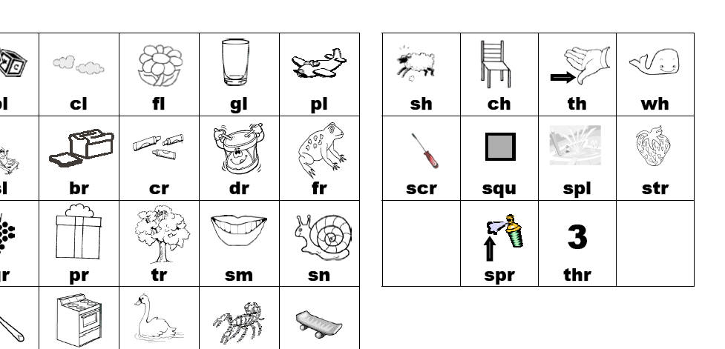
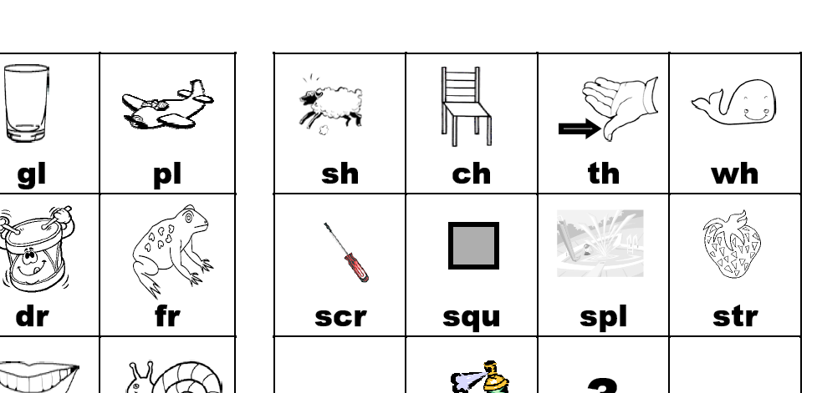
Blends |  |  | bl  blocks
br  bridge | cl  cloud | cr  crayons | dr  drum
fl  flag | fr  frog | gl  glass | gr  grapes
pl  plane | pr  pretzel | sc  scarecrow | sk  skeleton
sl  slide | sm  smile | sn  snail | sp  spoon
st  stove | sw  swing | tr  tree | tw  twelve
ch  chair | sh  sheep | wh  whistle | th  thumb

