COIN | VALUE | HEAD | TAIL
Penny | 1¢ | 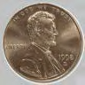 | 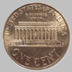
Nickel | 5¢ | 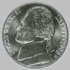
Dime | 10¢ | 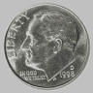 | 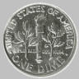
Quarter | 25¢ | 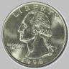 | 