Name:__________________________________Date__________________________
Rabbits in a Row

Cut out each box.
Glue the rabbits in order. Your teacher will give you paper to glue your rabbits to.
Then read the clues to find out each rabbits name. (Clues are on the next page)
Write each rabbits name below the picture:

First Ninth Seventh
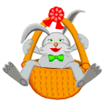
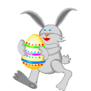
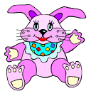

Second Fourth Third

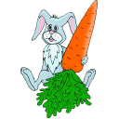
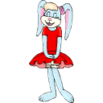
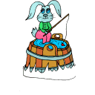

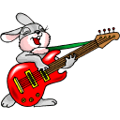
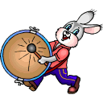
Sixth Fifth eighth

1.) The rabbit with the green bow ties is named Patrick.

2.) Patrick is sitting next to Malachi.

3.) Kelsey is holding an egg.

4.) Jaylyn is the only rabbit that is waving.

5.) Austin is the rabbit holding the carrot.

6.) Colleen is between Malachi and Austin.

7.) Alicia is the rabbit who is fishing.

8.) Roman plays the guitar.

9.) Brittany like to hit the drum.

