Color each bear. Sort your counting bears by their color. Write the number of colored bears in each circle.
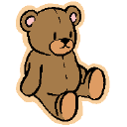

Blue
Red
Green

Yellow
Orange
Brown

Black
Purple

Copyright 2003 Teaching is a Work of Heart www.teachingheart.net

