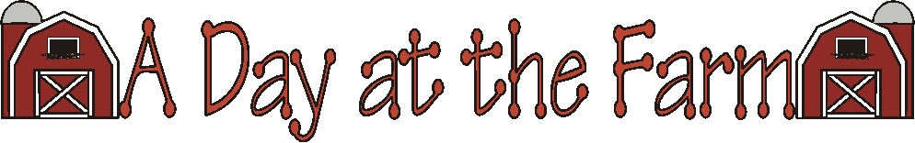

Words By Colleen Gallagher
Graphics by Lisa @ www.countryclipart.com
Or by Microsoft Office 2004

Created by – http://www.teachingheart.net copyright 2004 Artwork Copyright © 1998-2004 Original Country Clipart by Lisa www.countryclipart.com

Who is that at the farm?
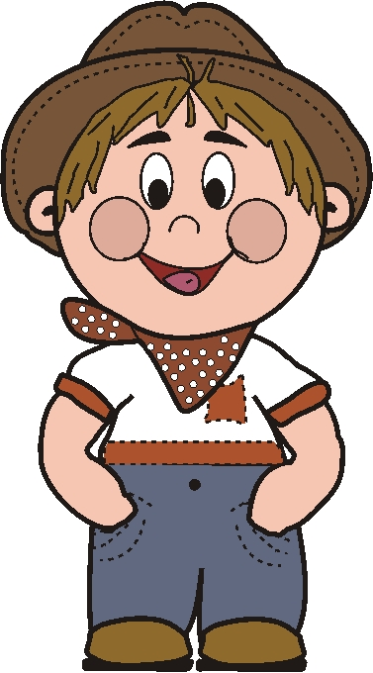

That’s farm boy Joe.
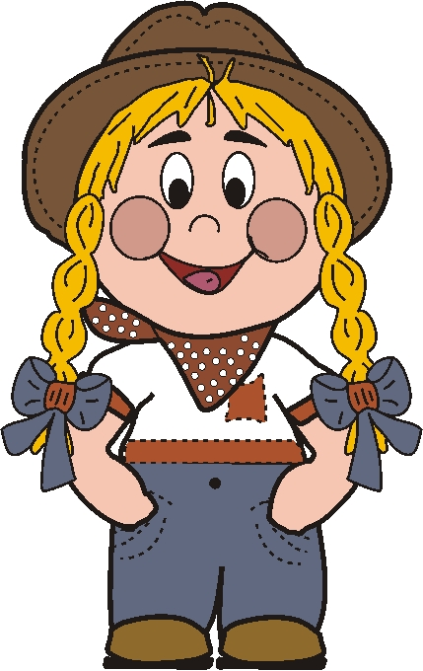
Who is that at the farm?

That is farm girl Jen.
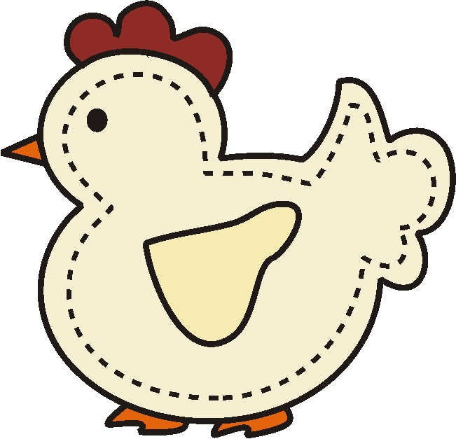
What do Jen and Joe see?

They see the chicken clucking.
What do Jen and Joe hear?
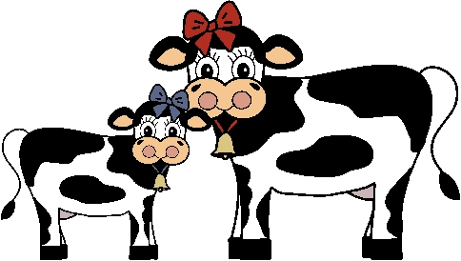

They hear cows mooing.
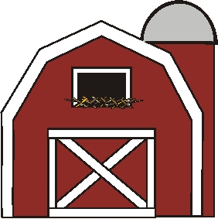
What do Jen and Joe smell?

They smell the hay in the barn.

Created by – http://www.teachingheart.net copyright 2004 Artwork Copyright © 1998-2004 Original Country Clipart by Lisa www.countryclipart.com

What do Jen and Joe feel?
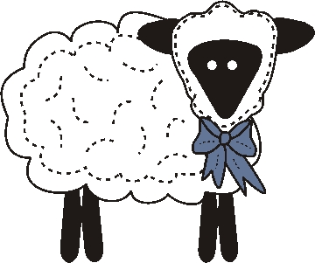

They feel the sheep’s soft wool.
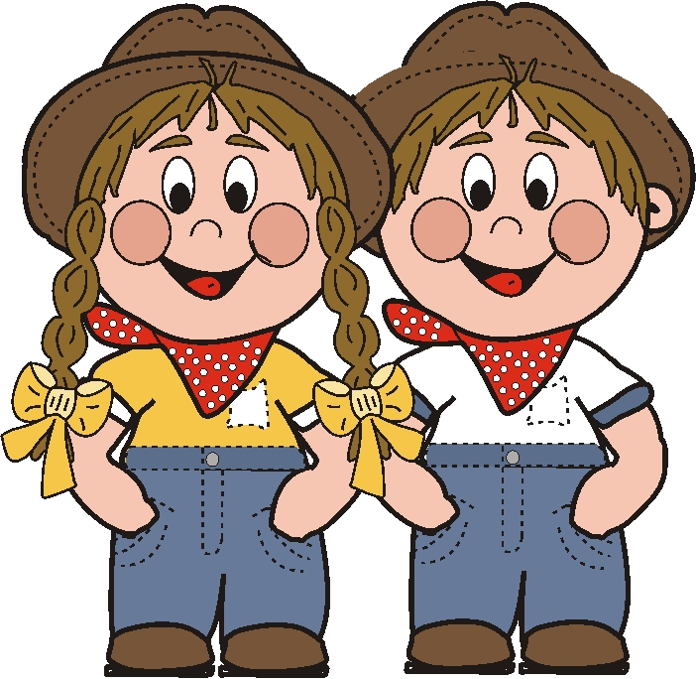
What do Jen and Joe say?

They say, “Thanks for visiting our farm!”
Created by – http://www.teachingheart.net copyright 2004 Artwork Copyright © 1998-2004 Original Country Clipart by Lisa www.countryclipart.com

