Who asked the spider that?
Name:____________________________________________ Date:___________________________________

Directions: Draw a line to match the sentence to the correct animal.


1.) “Want to go for a ride?”
2.) “Want to eat some grass?

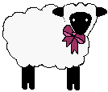
3.) “Want to run in the meadow?”

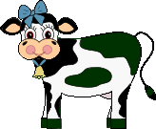

4.) “Want to jump on the rocks?”

5.) “Want to roll in the mud?”

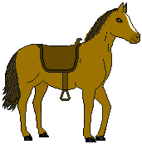
6.) “Want to chase a cat?”
7.) “Want to catch a pesty fly?

Directions: Imagine that the three animals below were in the story. What question would they ask the spider? Write the question they might ask on the line.

Mouse

Bat

Monkey

Sheet Copyright 2003 by C. Gallagher @ www.teachingheart.net / ARTWORK: Original Country Clipart by Lisa www.countryclipart.com @ 1998-2001 Country Graphics by Camille www.countrygraphics.com @ 2003

