Days of the Week

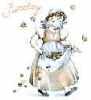Sunday Monday
Sunday’s child is fair and wise and good. Monday's child is fair of face,
Tuesday Wednesday
Tuesday's child is full of grace, Wednesday's child is full of woe,
Thursday 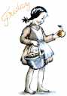Friday Thursday's child has far to go, Friday's child is loving and giving,
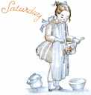Saturday Saturday's child must work for a living.
.

