Notes To Teacher:
This is a center for your pocket chart. This will help your students work on rhymes. They match words to the picture they rhyme with. After they finish the center you may choose for them to complete the center sheet found on the last page.

How to make this:
Print the pictures and words on cardstock. Laminate and cut. Place the pictures in the top row of your pocket chart. Place the words in a basket near the chart.

Your students will pick a card from the basket and place it under the picture that rhymes with the word. Each picture will have four words under it when the student has finished the center. They may complete the center sheet next.


baseball | small
tall | call


bell | tell
yell | well


car | far
tar | Jar


band | land
hand | brand

Name:__________________________ Date:____________________

Color the pictures. Under each picture, list the rhymes you found at the pocket chart!

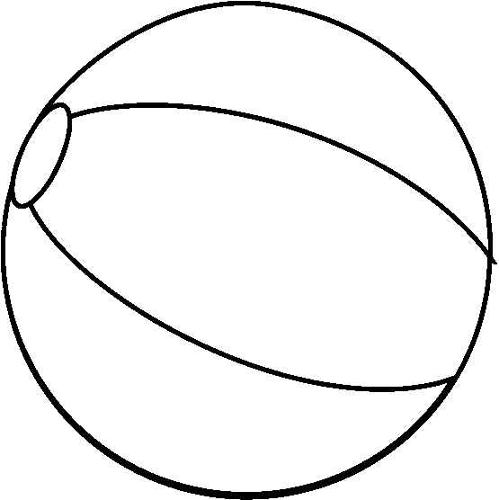ball | shell
star | sand

Read the sentence and underline the words that rhyme with wish.

Dad caught a fish and put it on a dish.

Created by – http://www.teachingheart.net copyright 2004 Artwork Copyright © 1998-2004 Original Country Clipart by Lisa www.countryclipart.com

