Name:___________________________________________

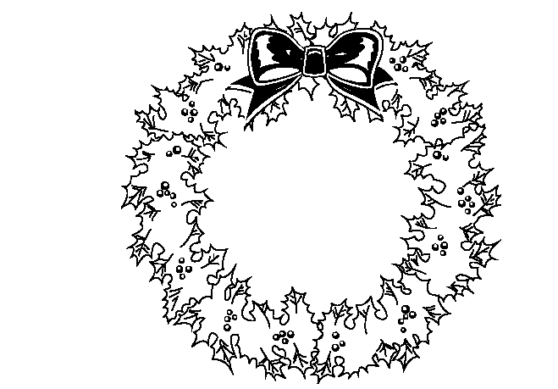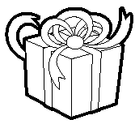
Stocking Ornament Candy Cane Wreath Snowman Present Tree

