Make a book: Have your students write the missing number in their Chicka Books. When they have finished, help them cut apart the pages and staple together to form a mini book. Have them share this book by reading it to a friend and an adult at home.
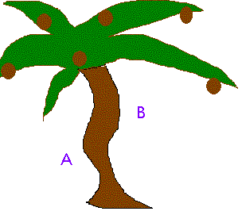
My Chicka Boom Boom
Book
Name: _______________________________
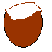  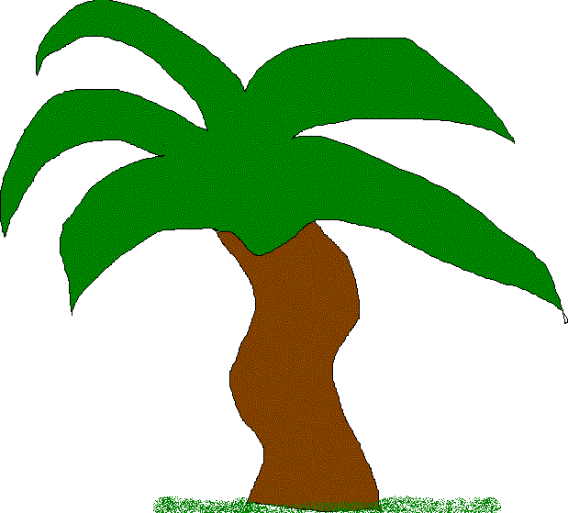  _________________ coconuts fell from the tree. | _________________ coconuts fell from the tree.
Copyright 2003 www.teachingheart.net
_________________ coconut fell from the tree. | _________________ coconuts fell from the tree.
_________________ coconuts fell from the tree. | _________________ coconuts fell from the tree.
Copyright 2003 www.teachingheart.net
Graphics by C. Gallagher

