COIN | VALUE | HEAD | TAIL
Penny | 1 cent | 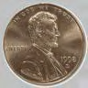 | 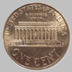
Nickel | 5 cents | 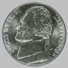
Dime | 10 cents | 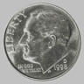 | 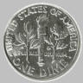
Quarter | 25 cents | 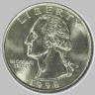 | 