A Reminder

We will be having a spelling

test on ___________________

Please help your child study

so that he/she is ready for

the test!
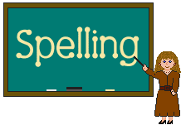

Created by – http://www.teachingheart.net copyright 2002 Artwork Copyright © 1998-2002 Original Country Clipart by Lisa www.countryclipart.com

