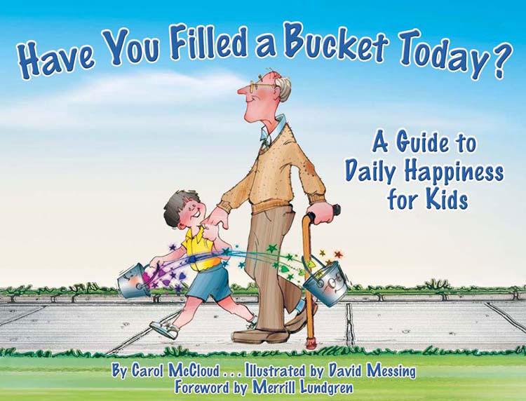
File attachedBucket Filling Activities

These three activities are designed to be used after reading, Have You Filled A Bucket Today.

The activities are:

- Whole class instruction: Pocket Chart
- Small group instruction (2-4 students at a time): Fill a Bucket Game
- Take Home Sheet

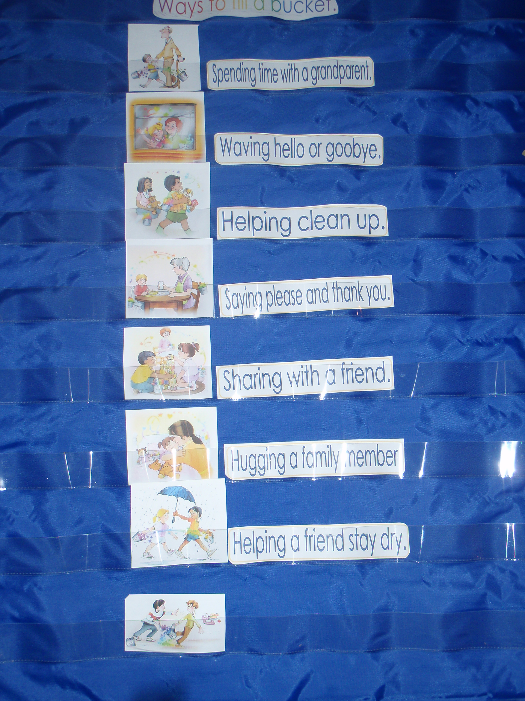
1.) Whole Class Instruction: Pocket Chart
After reading the book to your class, display the given graphics. You can display the graphics on a pocket chart or you may choose to place magnets on the graphics to display on a magnetic white board.

Tell the students that you will be talking about ways to fill a bucket. Read one of the sentences and ask a student to place the sentence under the picture that matches the statement. Discuss the picture. Repeat until all sentences are under the correct picture. Can your students find the picture showing a child who is bucket dipping? Remove that picture. Discuss other things we can do to fill buckets rather than dip into buckets.

Some Ideas for more discussion:
Something we could do for a friend.
Some kind statements we could make to our friends.
Discuss ways we can help at home and at school.
Discuss ways we can help our siblings or pets.

2.) Small Group Instruction: Fill A Bucket Board Game:
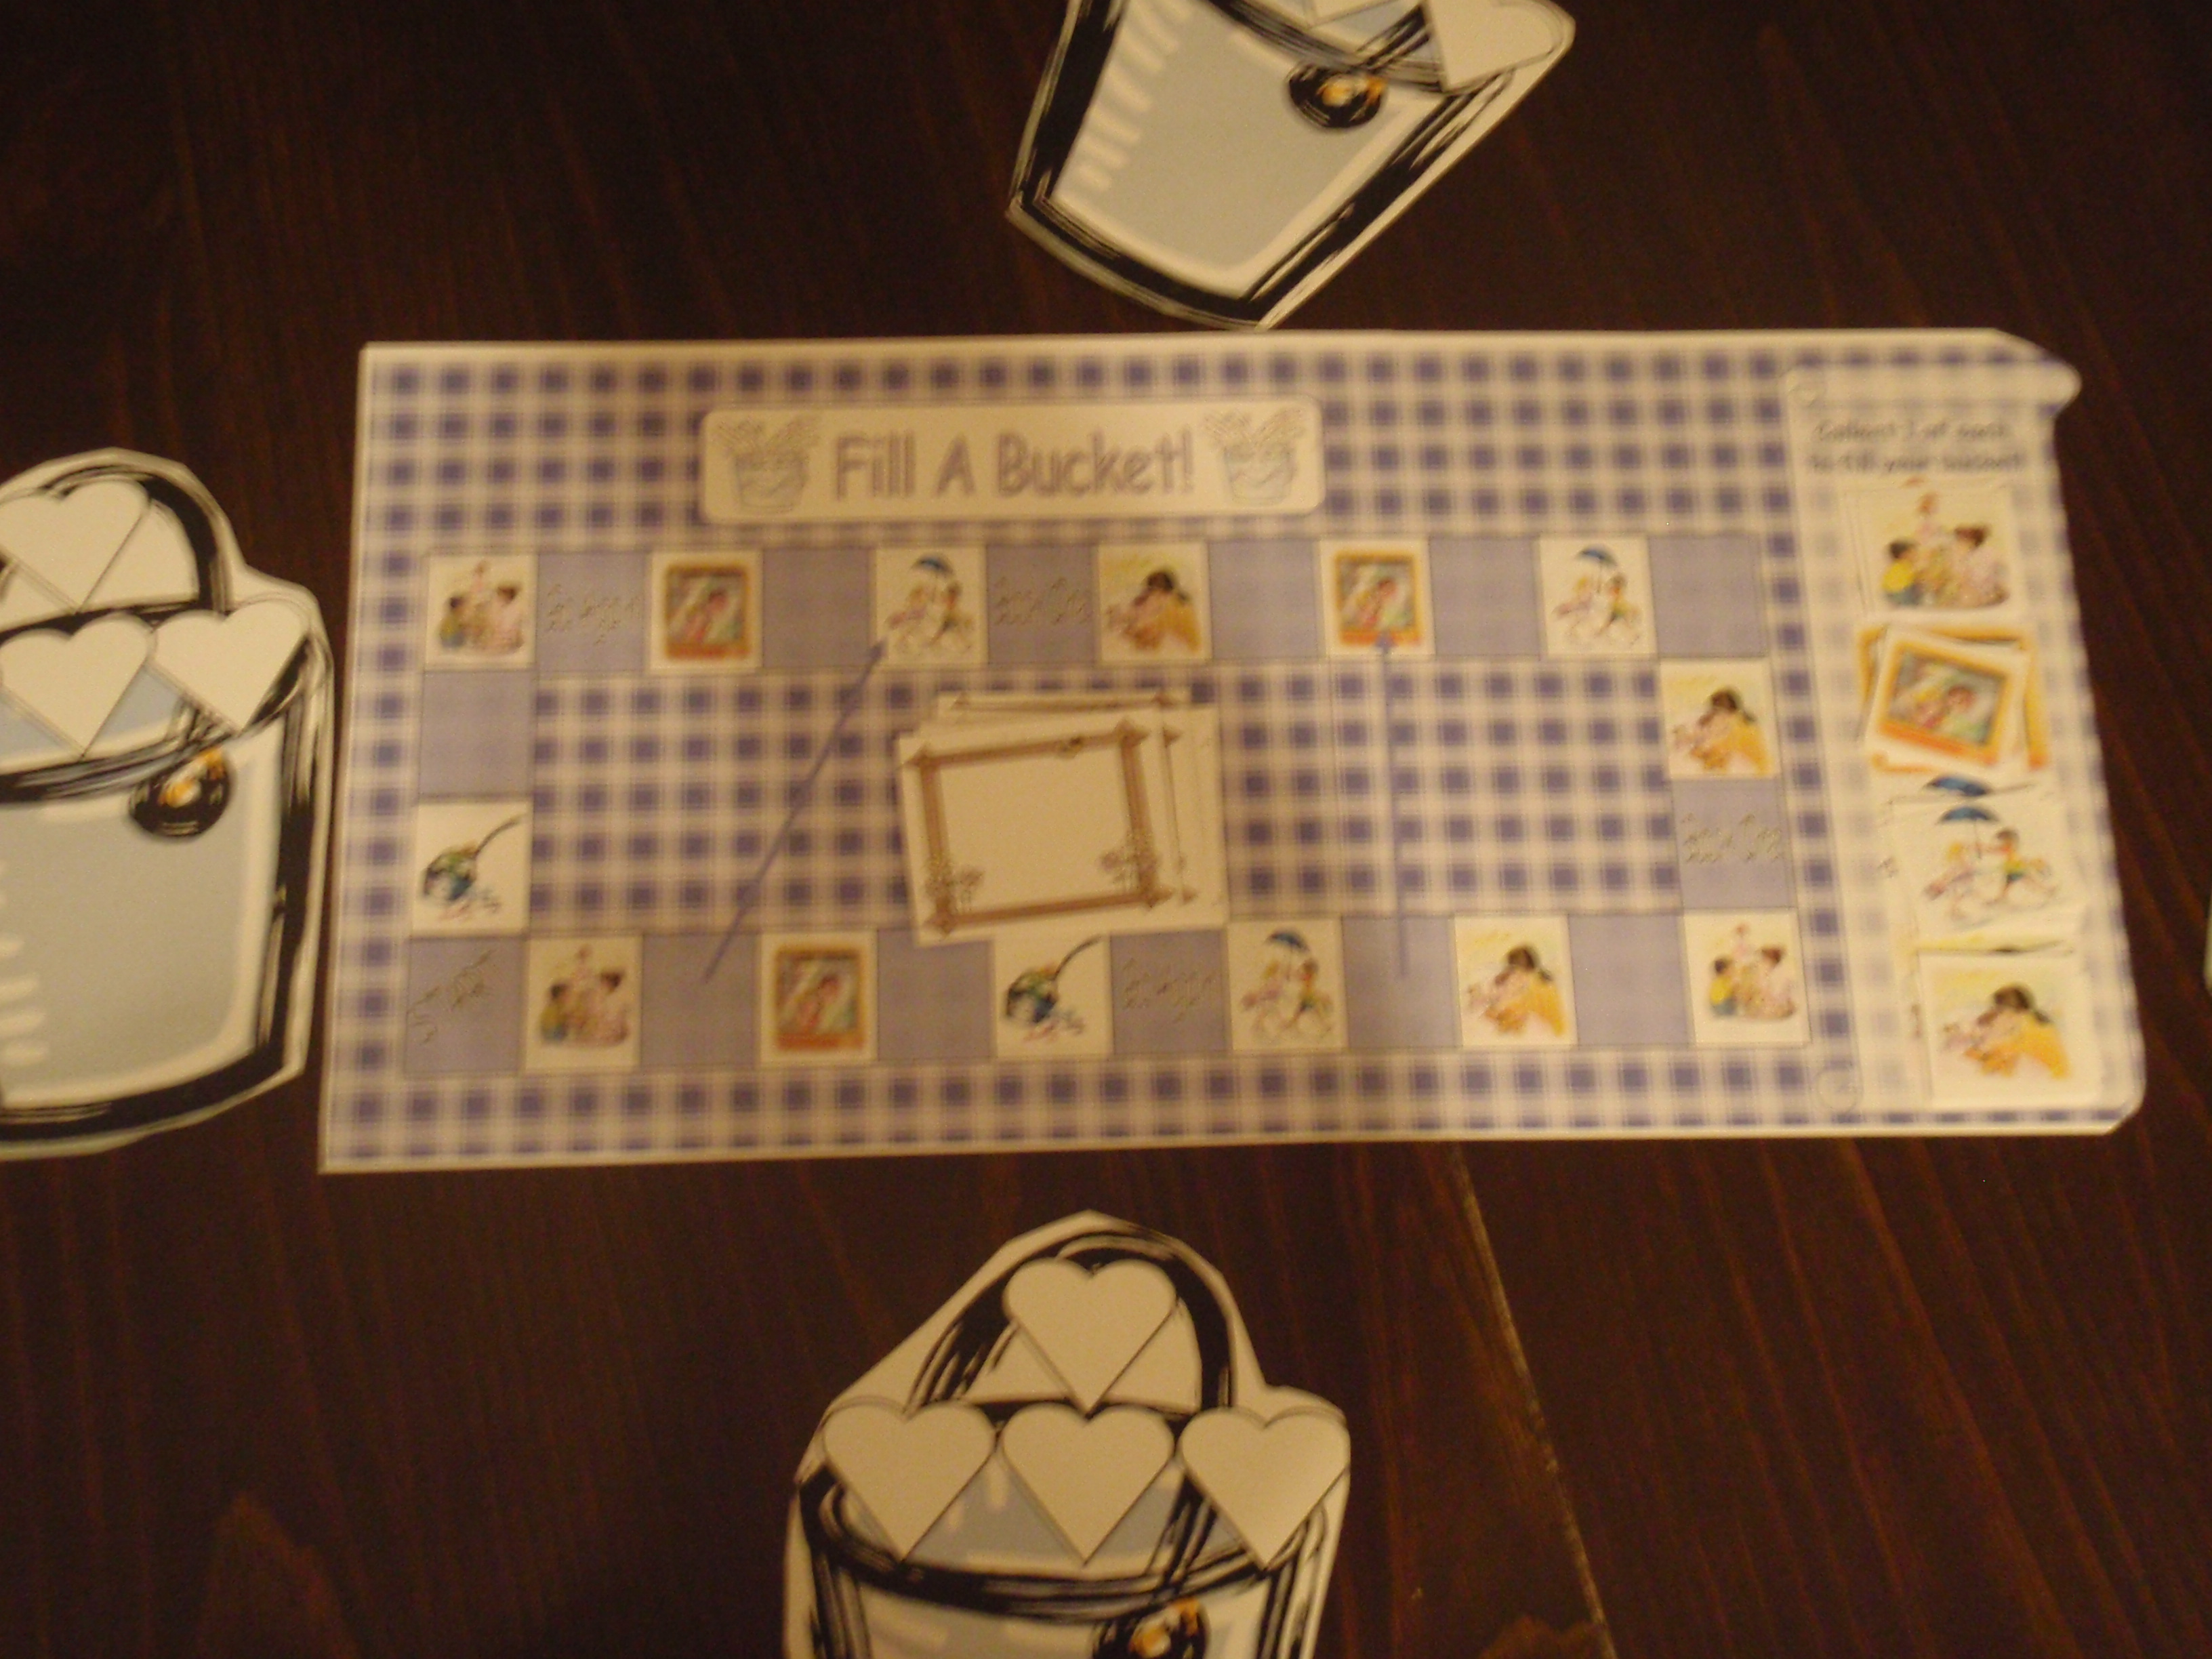
When: Use after you have read the book and after you have completed the whole class instruction with the pocket chart activity.

Objectives:
a.) To reinforce lessons learned through the book and pocket chart activity.
b.) Remind players of ways to fill a bucket with visual representations.
c.) Practice reading numbers one through six.
d.) Practice counting to six and moving an object a given number of spaces.

Game Play

Number of players: 2-4 players.
I suggest that you use this activity as part of a center rotation. 2-4 preschool students would work with the teacher or classroom helper to complete the game. Each player should be given a bucket and a marker to place on start.
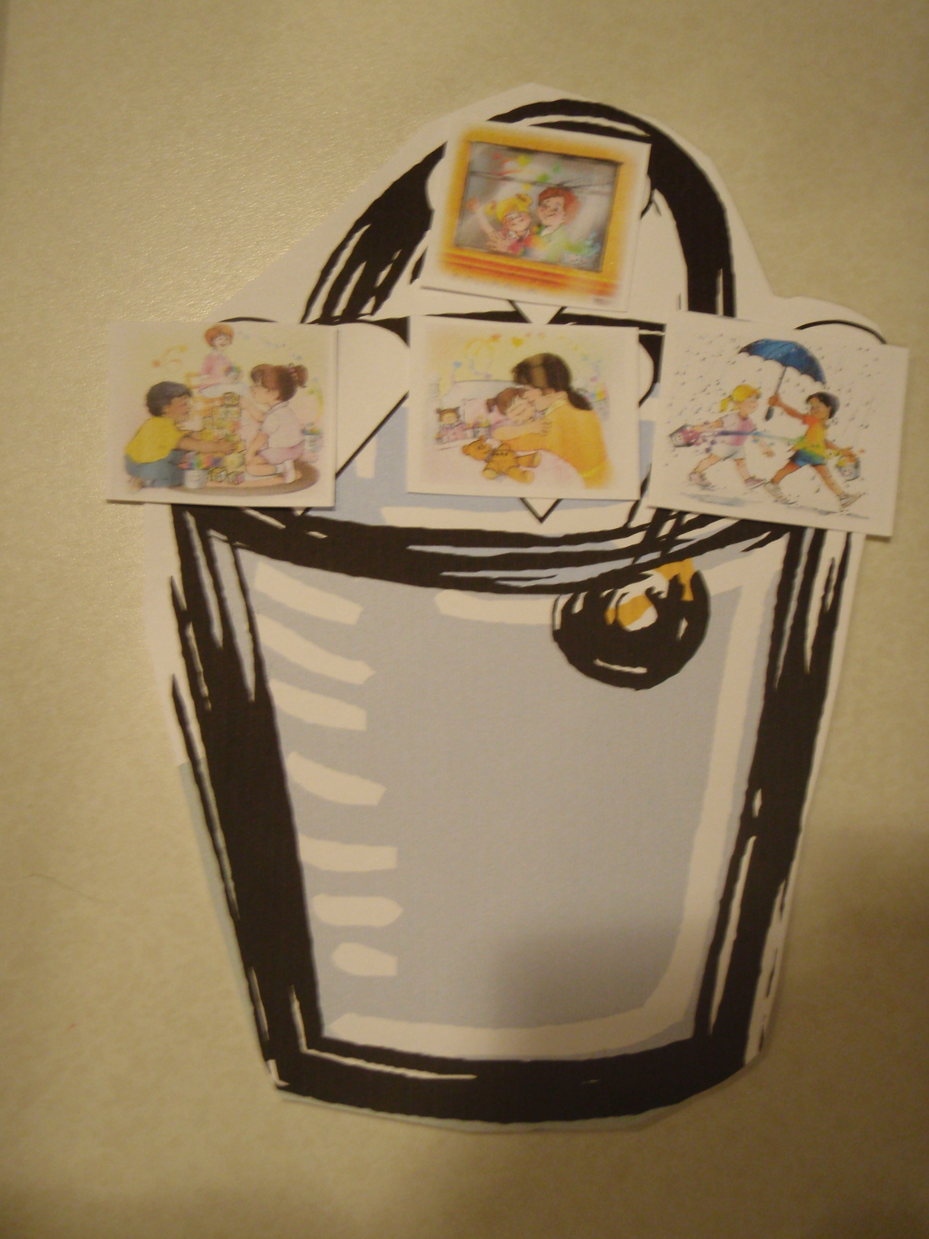
The object of the game:
The object of the game is for each player to fill his or her bucket with four different pictures that represent bucket filling.

Set Up:
Place the playing pieces on the board over the given picture under the words collect 1 of each to fill your bucket.

Place the number card shuffled and face down on the board.

Before Play:
Discuss each of the four pictures with your students and remind them that each picture shows someone filling another person’s bucket. Remind them that when we fill other people’s buckets with kind words and by doing nice things for them, we are also filling our own buckets. In this game, you will try to collect the four bucket filling pictures to place on your bucket. When your bucket is full, you did it!

To Play:
Students take turns drawing a number card and moving the given number of spaces on the board. If they land on a picture of bucket filling that they do not already have, they may take one and put it on a heart on their bucket. If they land on a bucket dipper they must put one of their bucket pictures back on the board. Help your students follow the cues on the board as they navigate through the game. Once they have four different bucket filler pictures on their card, tell them that they are Great Bucket Fillers!!!!

3.) Take Home Sheet
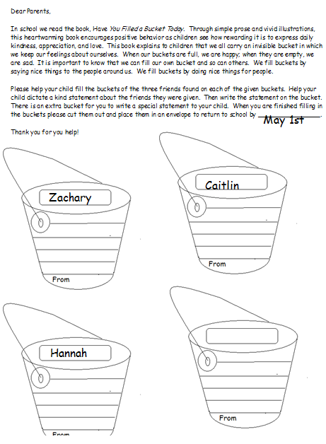
The last activity is a reproducible activity sheet. You will need to make copies for each student. On each child’s sheet, write the names of three students the given child should write a bucket filling statement for. On the last bucket, write the students name for the parent to write a statement about.

The sheet asks the students (with a parents help) to write a nice statement about three of their classmates. The student dictates the sentence and the parent writes the sentence on the correct bucket. There is also a space for the parent to write something nice about their child. Lastly, they should cut out the buckets and send them back into school.

Option: You could complete this activity at school rather than sending it home.

When the bucket statements are sent back to school, you will need to make an envelope for each child. Stick the statements written about that child in their envelope. Add a statement that you have written about each child to be included in the envelope. Send the envelope home for the parents to share with their child. Now you have filled up the buckets of your students.

