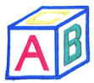
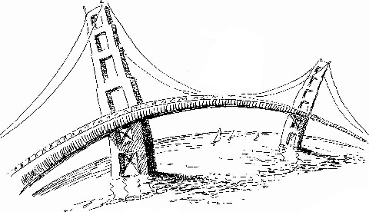

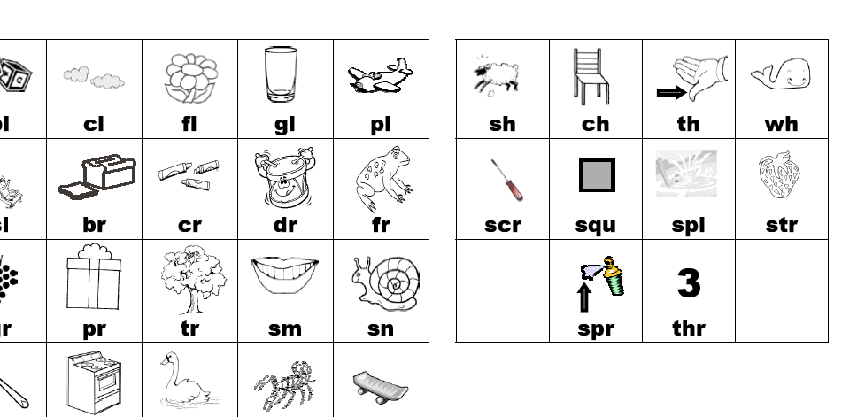
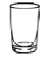
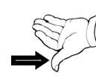
Blends |  |  | bl  blocks
br  bridge | cl  cloud | cr  crayons | dr    drum
fl    flag | fr  frog | gl  glass | gr  grapes
pl  plane | pr  pretzel | sc  scarecrow | sk  skate board
sl  slide | sm  smile | sn  snail | sp  spoon
st  stop | sw  swing | tr  tree | tw  twelve
ch  chair | sh  sheep | wh  whistle | th  thumb

