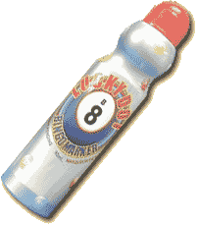

Name:_______________ _________________________________ Date:____________________________

Directions: Use your Bingo Dauber to daub the number of circles that answer the math problem.

Now may your own problem!

________ + ________ = ________

Copyright 2009 C. Gallagher at www.teachingheart.net

