Words By Colleen Gallagher  Graphics by Lisa @ www.countryclipart.com  Or by Microsoft Office 2004  Name:________________________________ | Who is that at the farm?  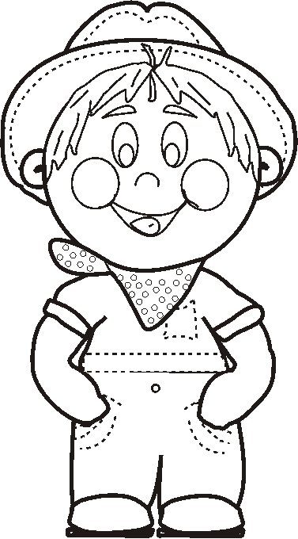  That’s farm boy Joe.
Who is that at the farm?  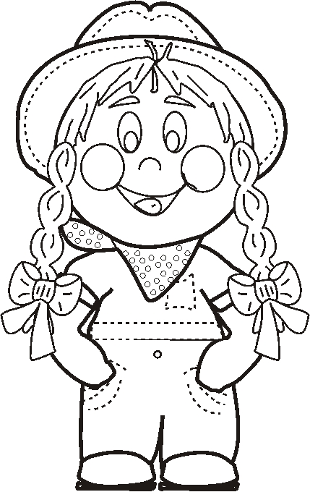  That is farm girl Jen. | What do Jen and Joe see?  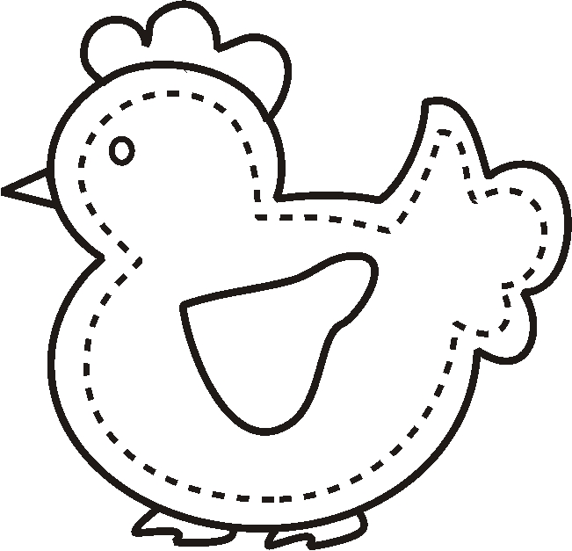  They see the chicken clucking.

What do Jen and Joe hear?  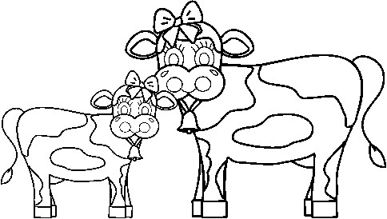  They hear cows mooing. | What do Jen and Joe smell?  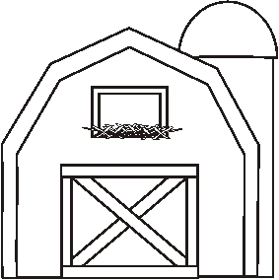  They smell the hay in the barn.
What do Jen and Joe feel?  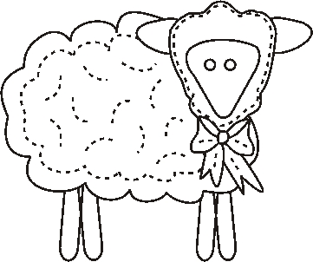  They feel the sheep’s soft wool. | 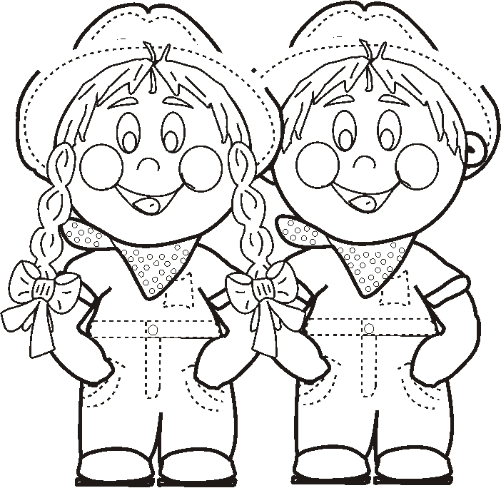  What do Jen and Joe say?  They say, “Thanks for visiting our farm!”
Created by – http://www.teachingheart.net copyright 2004 Artwork Copyright © 1998-2004 Original Country Clipart by Lisa www.countryclipart.com

